Production Function
Production Function is the relationship between physical inputs (land, labour, capital, etc.) and physical outputs (quantity produced). It is a technical relationship that studies material inputs on one hand and material outputs on the other hand. Material inputs include variable and fixed factors of production.
In a standard equation, the Production function is represented by Q, Labour (Variable element) is represented by L, and Capital (Fixed element) is represented by K.
Q = f(L,K)
In the words of Watson, "Production Function is the relationship between a firm's production (output) and the material factors of production (input)."

Graphical Representation of Production Function

For example, When there are 4 units of labour and 5 units of capital, the equation for the production function is Q = f(4,5)

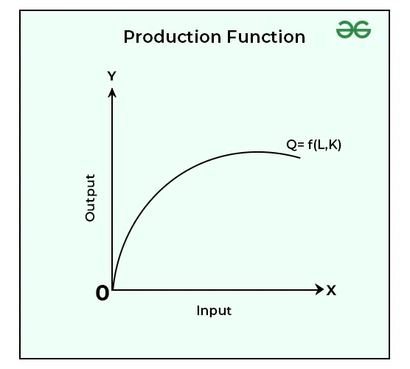

In the above graph, X-axis represents inputs that are being used in the production process and Y-axis represents outputs that get produced. Q is the Production Function.

