OFFICE OF THE PRINCIPAL
BHAWANIPUR HASTINAPUR BIJNI (B.H.B.) COLLEGE, SARUPETA
Accredited by NAAC (Third Cycle) with CGPA of 2.93 on Seven Point Scale at B++ Grade
P.O.: SARUPETA, DIST.: BARPETA
ASSAM, PIN – 781318
From - Website: www.bhbcollege.ac.in
Dr. Nayan Jyoti Das, M.A., Ph.D Email- principalbhbcollege18@gmail.com
Principal principalbhb2018@gmail.com
Ph. (03666) 299983, 9954934342
Memo. No.: BHBC/ Date: 17-11-2024

Report of One day workshop on placement opportunity
One day workshop on Placement opportunity was organized at B.H.B College Sarupeta on 28/08/2023 by career Counselling Cell, B.H.B College in collaboration with Micro –Tech, sarupeta. Mr.NayanJyoti Talukdar, Assistant Professor, Dept of English,was the Chairperson of the programme. Dr. Purubi Talukdar inaugurated the programme by giving welcome speech.
Mr.Faridor Rahman was invited asa resource person. In the workshop, the resource said about the important of Computer Knowledge. He also said the different course provided in the Micro- Tech Institution. He spoke about the importance of computer diploma in the present job application. In this fast changing World, importance is given on Technology. He said that everyone should learn how to use technology in our daily life. From the workshop the students learned the importance of Technology and its advantage in the daily uses. After long lecture by the Resource person and votes thanks was given by the Dr. Purubi Talukdar.
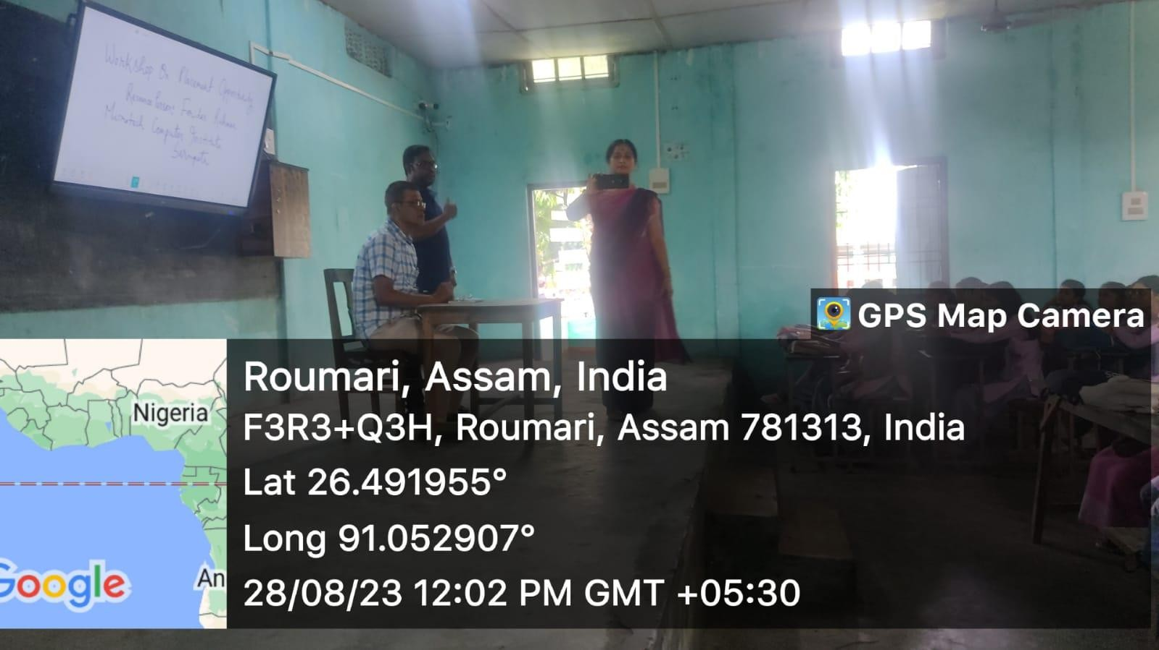

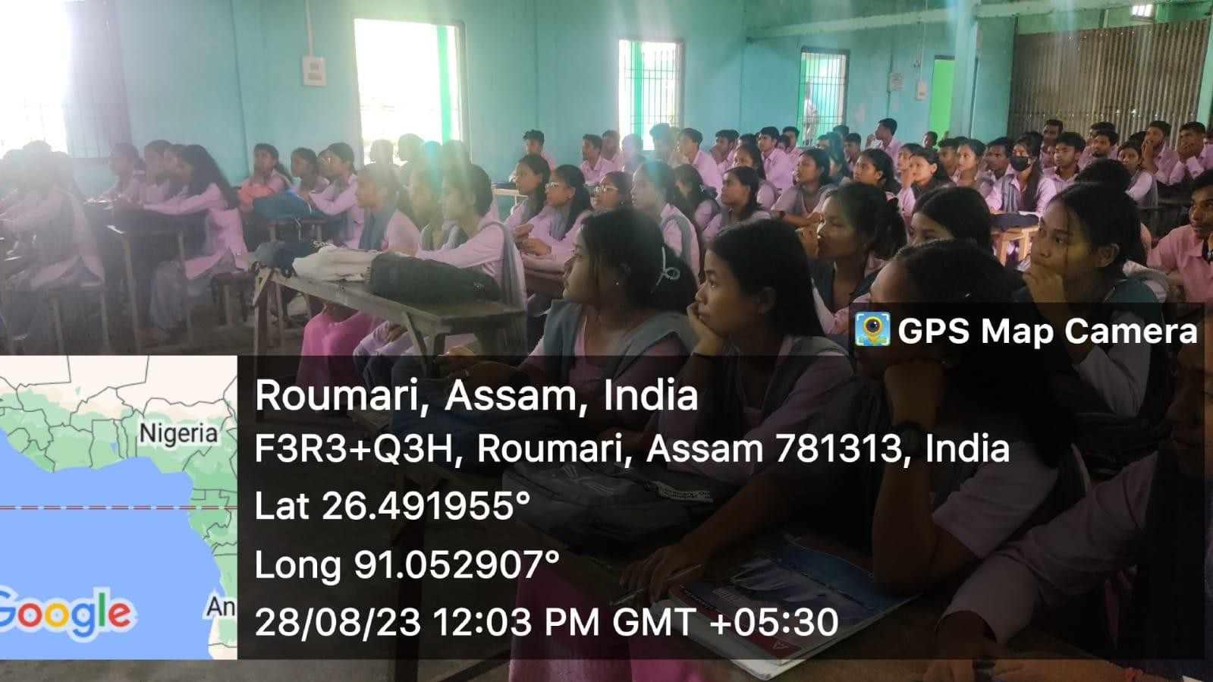
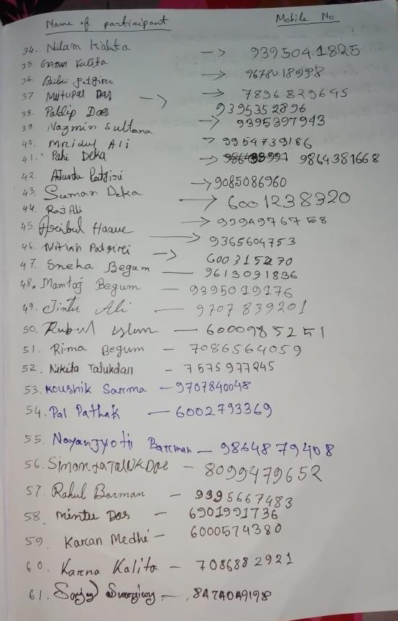
Signature of the students
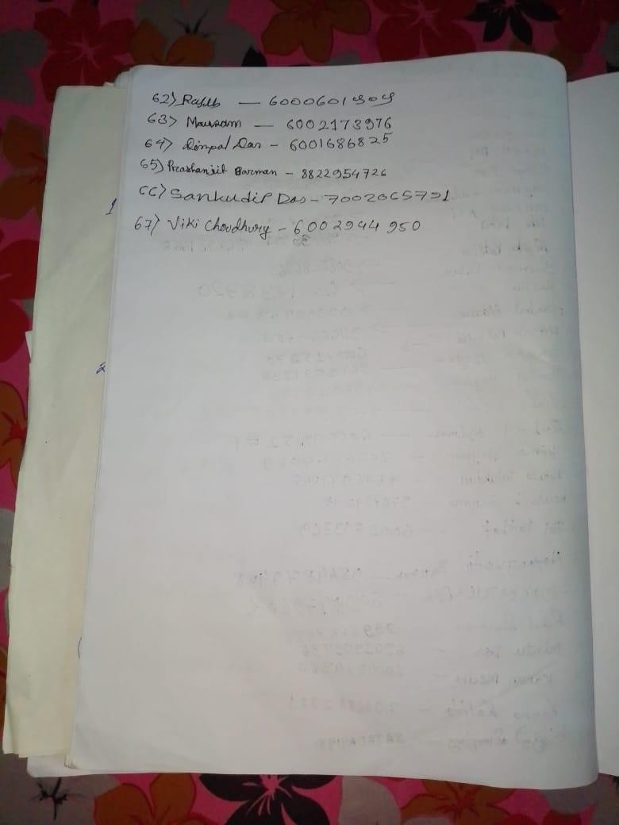
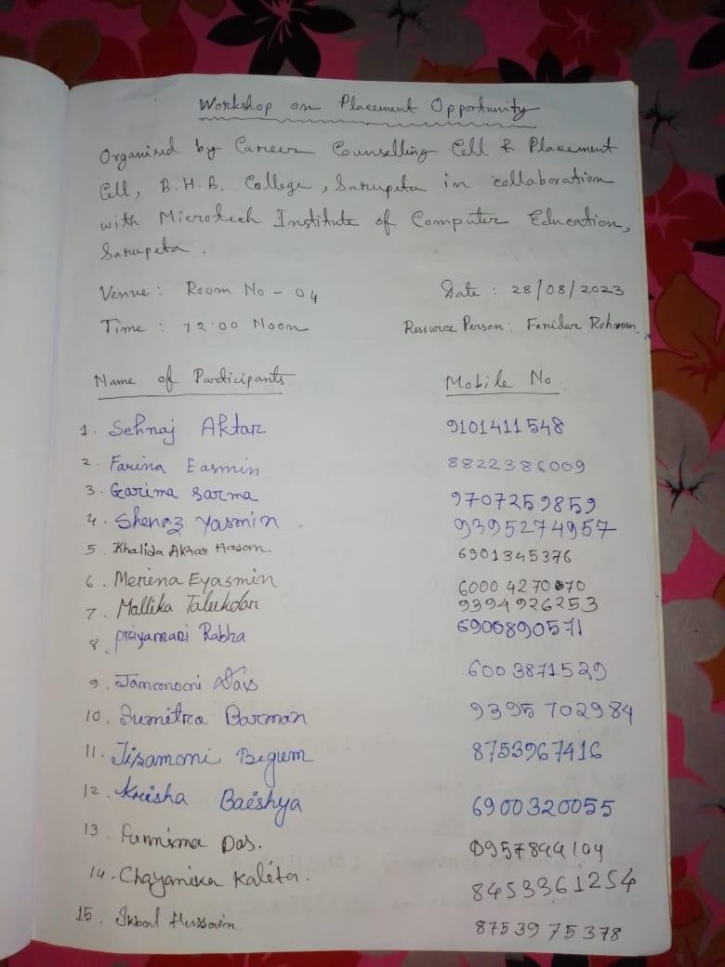
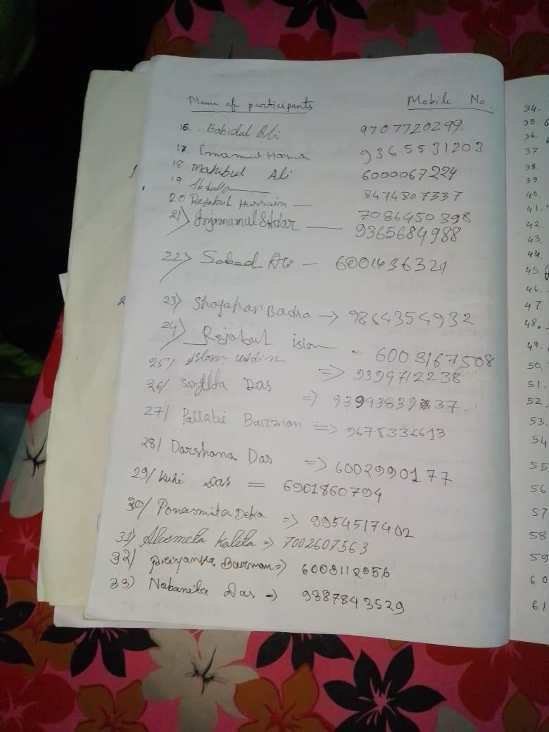


Yours faithfully

Principal,
B.H.B. College, Sarupeta


OFFICE OF THE PRINCIPAL
BHAWANIPUR HASTINAPUR BIJNI (B.H.B.) COLLEGE, SARUPETA
Accredited by NAAC (Third Cycle) with CGPA of 2.93 on Seven Point Scale at B++ Grade
P.O.: SARUPETA, DIST.: BARPETA
ASSAM, PIN – 781318
From - Website: www.bhbcollege.ac.in
Dr. Nayan Jyoti Das, M.A., Ph.D Email- principalbhbcollege18@gmail.com
Principal principalbhb2018@gmail.com
Ph. (03666) 299983, 9954934342
Memo. No.: BHBC/ Date: 17-11-2024

A Brief Report on Workshop of “Bio-Diversity Challenges and Responsibilities” on 14th June, 2023 at Digital Seminar Hall, B.H.B. College, Sarupeta.
The Eco Club, B.H.B. College, Sarupeta organized a Workshop on “Bio-Diversity Challenges and Responsibilities” on 14th June, 2023 at Digital Seminar Hall, B.H.B. College, Sarupeta in collaboration with IQAC, B.H.B. College, Sarupeta. The Programme was hosted by Sobita Tokbipi, Assistant Professor, department of Education, B.H.B. College, Sarupeta. Dr. Nayan Jyoti Das, Principal, B.H.B. College, Sarupeta delivered a welcome speech. The resource person of the workshop was Mr. Kanak Chandra Das, Associate Professor, department of Botany, Bhattadeva University, Pathsala. In his speech he talked about causes of biodiversity loss pollution, destruction of habits, invasive alien species, overexploitation of the natural environment etc. Initiatives and frame works are emerging to guide for managing and reporting nature related risks in order to influence the I revaluation. 20 students and teaching and non teaching staff participated in the workshop. The workshop ended with the vote of thanks offered by Sobita Tokbipi.

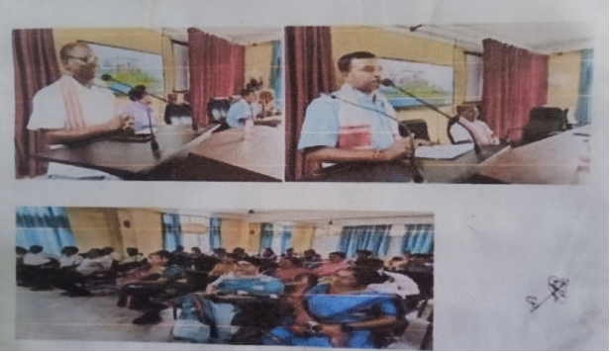

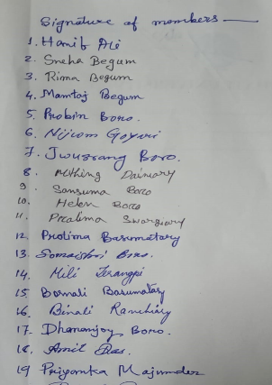 Yours faithfully

Principal,
B.H.B. College, Sarupeta


OFFICE OF THE PRINCIPAL
BHAWANIPUR HASTINAPUR BIJNI (B.H.B.) COLLEGE, SARUPETA
Accredited by NAAC (Third Cycle) with CGPA of 2.93 on Seven Point Scale at B++ Grade
P.O.: SARUPETA, DIST.: BARPETA
ASSAM, PIN – 781318
From - Website: www.bhbcollege.ac.in
Dr. Nayan Jyoti Das, M.A., Ph.D Email- principalbhbcollege18@gmail.com
Principal principalbhb2018@gmail.com
Ph. (03666) 299983, 9954934342
Memo. No.: BHBC/ Date: 17-11-2024

Report on Equality and Discrimination
Equal Opportunity Cell, B.H.B College, Sarupeta organized a Seminar on Equality and Non Discrimination based on Sexual Orientation and Gender Identity for students and faculty of the college. The programme was inaugurated by Dr. Nayan Jyoti Das, Principal, B.H.B College. He told that Equality and discrimination are like two sides of the same coin. Equality means absence of discrimination and. discrimination means absence of equality.
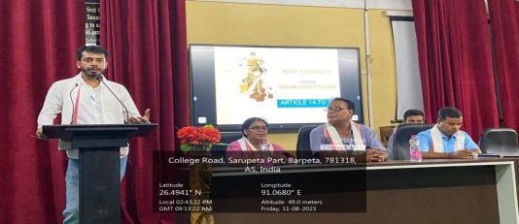
Discrimination violates basic human rights and has wider social and economic consequences. Mr. Rajarshi Choudhury, young lawyer of sarupeta was the resource person of the lecture. On his lecture he highlighted that people may misuse their freedom and fail to respect others as equal. Demands for equal treatment can involve restrictions on people's freedom to act. The lecture was ended by the vote of thanks from Dr. Preeti Rekha Dutta, Assistant Professor, B.H.B College. Almost 54 participants are present in the meeting including students and faculty.

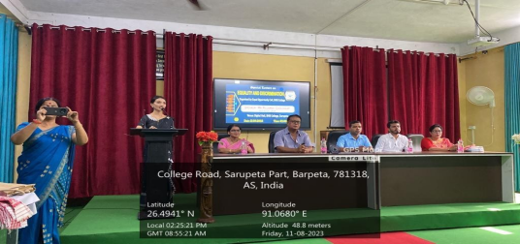

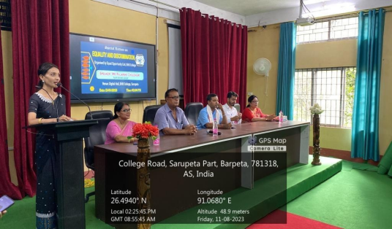

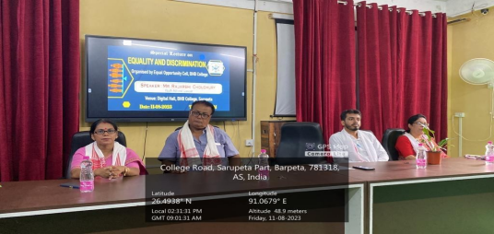

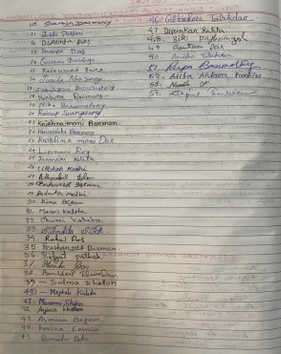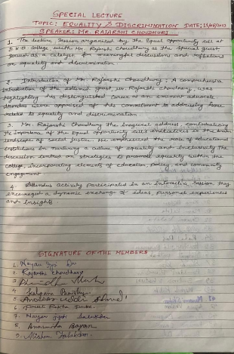
Yours faithfully

Principal,
B.H.B.College,Sarupeta

OFFICE OF THE PRINCIPAL
BHAWANIPUR HASTINAPUR BIJNI (B.H.B.) COLLEGE, SARUPETA
Accredited by NAAC (Third Cycle) with CGPA of 2.93 on Seven Point Scale at B++ Grade
P.O.: SARUPETA, DIST.: BARPETA
ASSAM, PIN – 781318
From - Website: www.bhbcollege.ac.in
Dr. Nayan Jyoti Das, M.A., Ph.D Email- principalbhbcollege18@gmail.com
Principal principalbhb2018@gmail.com
Ph. (03666) 299983, 9954934342
Memo. No.: BHBC/ Date: 17-11-2024

Departmental Seminar

A Departmental Seminar was Organised by the Department of education in collaboration with Extension cell, B.H.B College,on 23/04/2024. The topic of the seminar was NEP, 2020, Education and Development. All the 6th Semester (Honours) participated and presented a paper of the topic. Dr. Purubi Talukdar,HOD, Department of Education, was the chairperson of the programme.

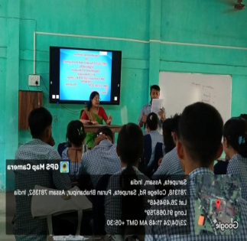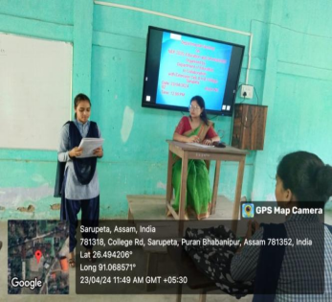

6th Semester (H) Students are presenting a seminar paper.

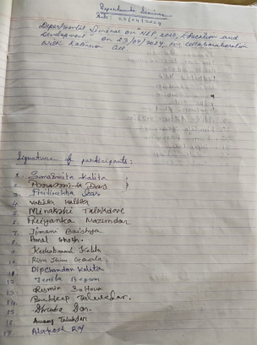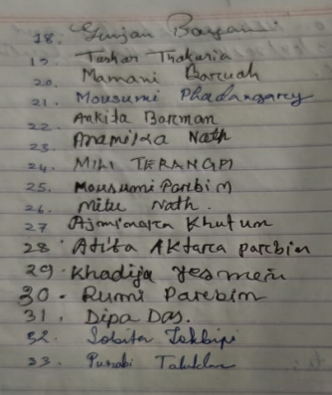

Yours faithfully

Principal,
B.H.B. College, Sarupeta

OFFICE OF THE PRINCIPAL
BHAWANIPUR HASTINAPUR BIJNI (B.H.B.) COLLEGE, SARUPETA
Accredited by NAAC (Third Cycle) with CGPA of 2.93 on Seven Point Scale at B++ Grade
P.O.: SARUPETA, DIST.: BARPETA
ASSAM, PIN – 781318
From - Website: www.bhbcollege.ac.in
Dr. Nayan Jyoti Das, M.A., Ph.D Email- principalbhbcollege18@gmail.com
Principal principalbhb2018@gmail.com
Ph. (03666) 299983, 9954934342
Memo. No.: BHBC/ Date: 17-11-2024

A Brief Report on Seminar on “Asamiya Kabitar Itihash Aru Abasthitir Parjalochana” on 20th May, 2024 at Room No - 4, B.H.B. College, Sarupeta :

The department of Assamese, B.H.B. College, Sarupeta organized a Seminar on “Asamiya Kabitar Itihash Aru Abasthitir Parjalochana” on 20th May, 2024 at Room No-4, B.H.B. College, Sarupeta in collaboration with Research Innovation and Extension Cell, IQAC, B.H.B. College, Sarupeta under Memorandum of Understanding of department of Assamese, B.H.B. College, Sarupeta and department of Assames,Bhawanipur Anchalik College, Bhawanipur. The Seminar was presided by Mofazzal Hussain, Associate Professor and HOD, department of History and Vice Principal of B.H.B. College, Sarupeta.The seminar was started with a welcome speech delivered by the President of Mofazzal Hussain. The programme was enchored by Preeti Rekha Dutta, Assistant Professor, department of Assamese, B.H.B. College, Sarupeta. The resource person of the seminar was Mr. Dilip Kumar Deka, Assistant Professor, department of Assamese, Bhawanipur Anchalik College, Bhawanipur. In his speech he talked about the history of Assamese poetry. Assamese poetry borrows many themes from Sanaskrit Literature and is mainly devotional in tone. The starting of Assamese Poetry is marked with the adaption from Sanaskrit Puranas in to Assamese by the poet scholar Hema Saraswati in the early 13th Century – he said. 64 students and teachers was participated in the Seminar. The Seminar was ended with the vote of thanks offered by Preeti Rekha Dutta.

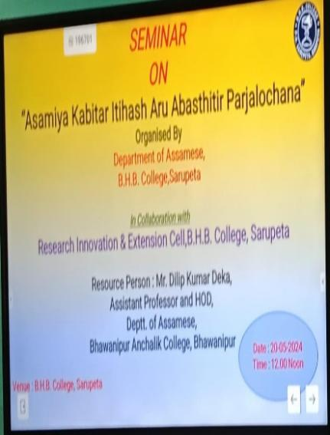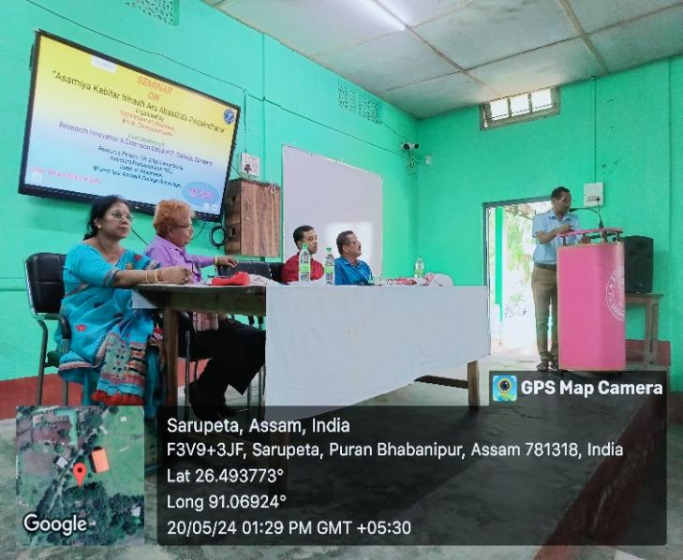

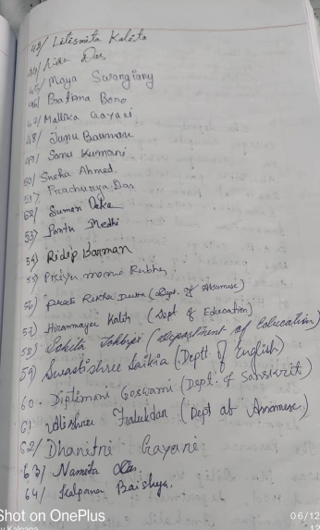
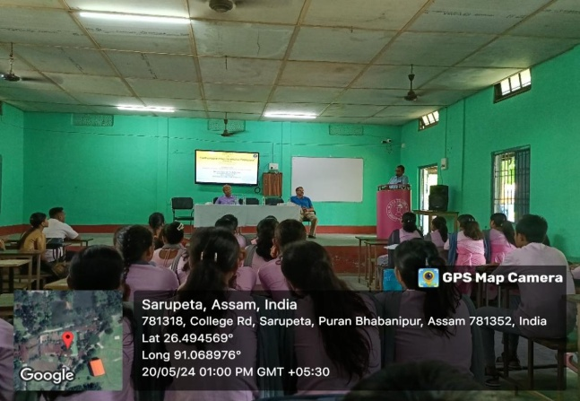

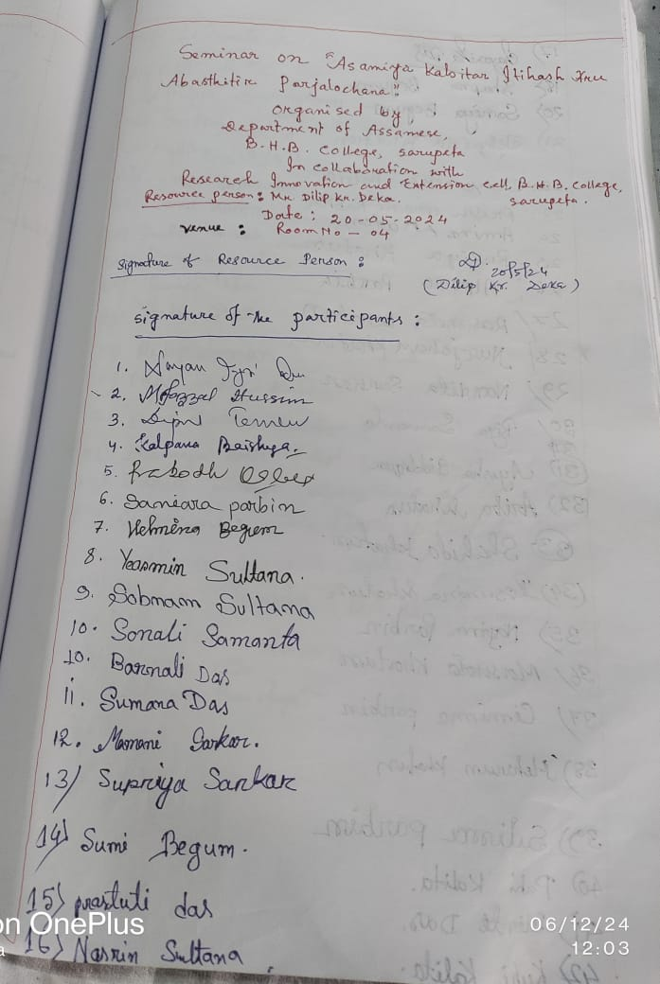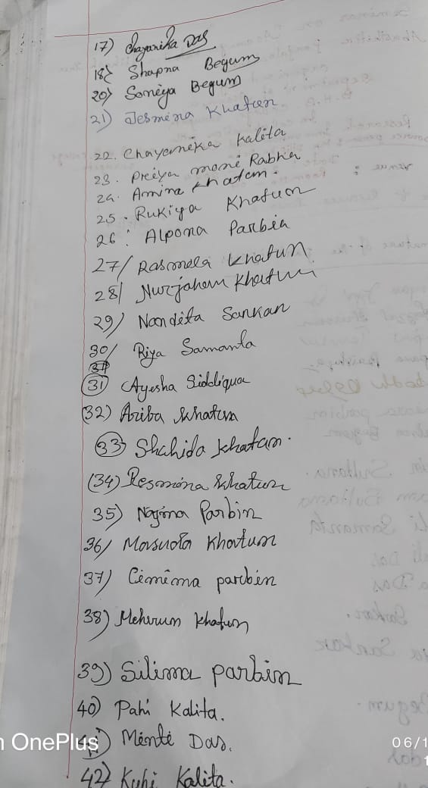

Yours faithfully

Principal,
B.H.B. College, Sarupeta

OFFICE OF THE PRINCIPAL
BHAWANIPUR HASTINAPUR BIJNI (B.H.B.) COLLEGE, SARUPETA
Accredited by NAAC (Third Cycle) with CGPA of 2.93 on Seven Point Scale at B++ Grade
P.O.: SARUPETA, DIST.: BARPETA
ASSAM, PIN – 781318
From - Website: www.bhbcollege.ac.in
Dr. Nayan Jyoti Das, M.A., Ph.D Email- principalbhbcollege18@gmail.com
Principal principalbhb2018@gmail.com
Ph. (03666) 299983, 9954934342
Memo. No.: BHBC/ Date: 17-11-2024

Seminar Presentation by Students , 2024
The department of political science organized a Seminar on the topic ‘Role of Communist Party in China’ on 5th April, 2024 under the resource persons of Dr. Dipti Kalita and Mr. Rajiv Thengal. Most of the honors students of the department participated in the Seminar. The Seminar was fruitful and enlightening to the students. Students discussed the growth of the Communist Party of China as single party, its role in the freedom struggle and politics of China. Students also discussed on the party’s ideology ‘Communism with Chinese Characteristics’, organizational structure and functioning of the party.

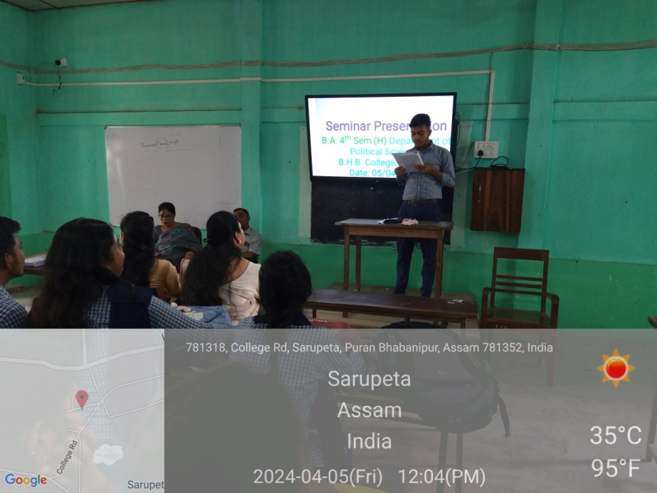
Semenar presentation by Bidyut Pathak on “Role of Communist Party in China”

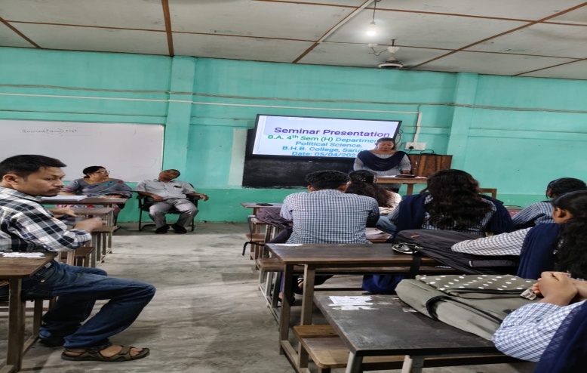
Semenar presentation by Barna Das on “Role of Communist Party in China”
Signatures of Participant Students
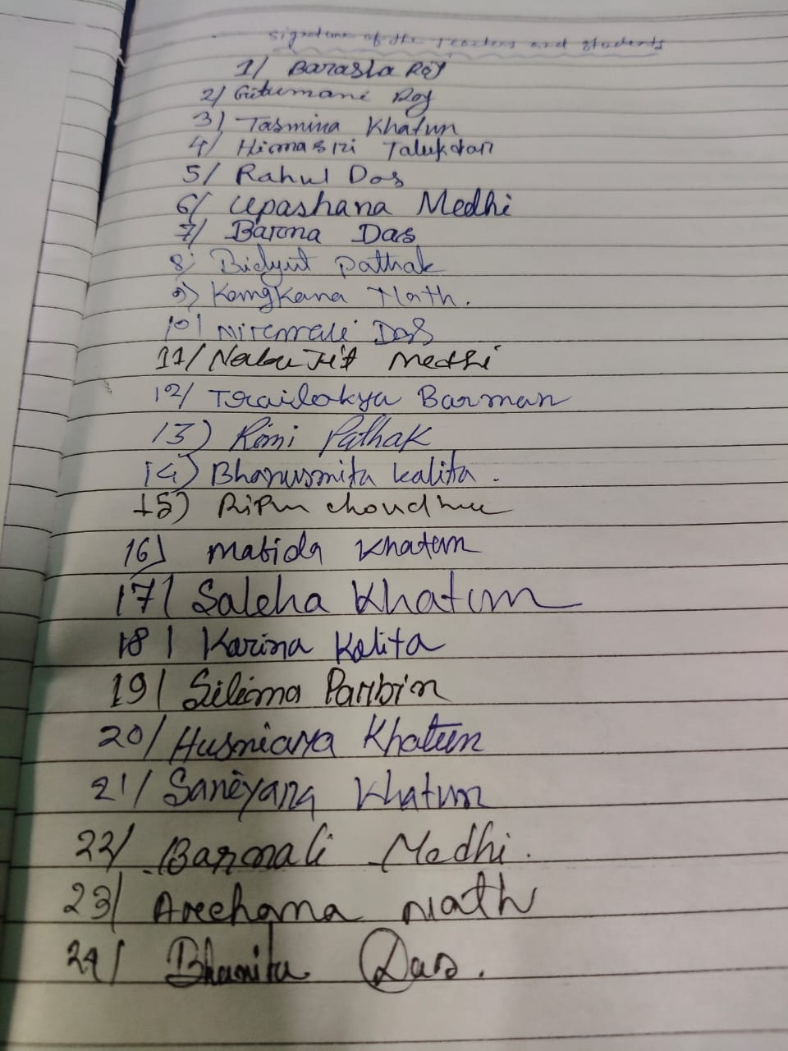

Yours faithfully
Principal,
B.H.B. College, Sarupeta

OFFICE OF THE PRINCIPAL
BHAWANIPUR HASTINAPUR BIJNI (B.H.B.) COLLEGE, SARUPETA
Accredited by NAAC (Third Cycle) with CGPA of 2.93 on Seven Point Scale at B++ Grade
P.O.: SARUPETA, DIST.: BARPETA
ASSAM, PIN – 781318
From - Website: www.bhbcollege.ac.in
Dr. Nayan Jyoti Das, M.A., Ph.D Email- principalbhbcollege18@gmail.com
Principal principalbhb2018@gmail.com
Ph. (03666) 299983, 9954934342
Memo. No.: BHBC/ Date: 17-11-2024

Report on workshop on Superstition, Prejudice and its impact
A workshop against Superstition, Prejudice and its impact was organized on 18May, 2024 at B.H.B College, Sarupeta by equal opportunity cell. Program was inaugurated by Dr. Nayan Jyoti Das, Principal, B.H.BCollege, Sarupeta.On this occasion Kanak Das, Associate Professor, Bhattadev University, Dr. Akshay Kumar Haloi, Bhattadev University were the guest speaker for the function. On this occasion Kanak Das elaborated his view on the matter how rural areas people become victim of various superstitions. He also pointed out that many people are educated but still they maintain various superstitions. It is mainly because they don’t apply their educational knowledge to fight those superstitions. Dr. Haloi enlightened the gathering through various “Chamatkar Prayog” based on superstition eradication. As well as Aswini Thakuria, Advisor, Assam Science Society, Sarupeta Branchhas shared his views on this occasion Dr. Preeti Rekha Dutta, Assistant Professor, Department of Assamese, B.H.B College, Sarupeta anchored the program and also proposed a vote of thanks. All the faculty members B.H.B College worked very hard for successful conduction of the program. Dr. Nayan Jyoti Das, Principal congratulated and given best wishes to students. Almost 117 participants were present in the workshop.
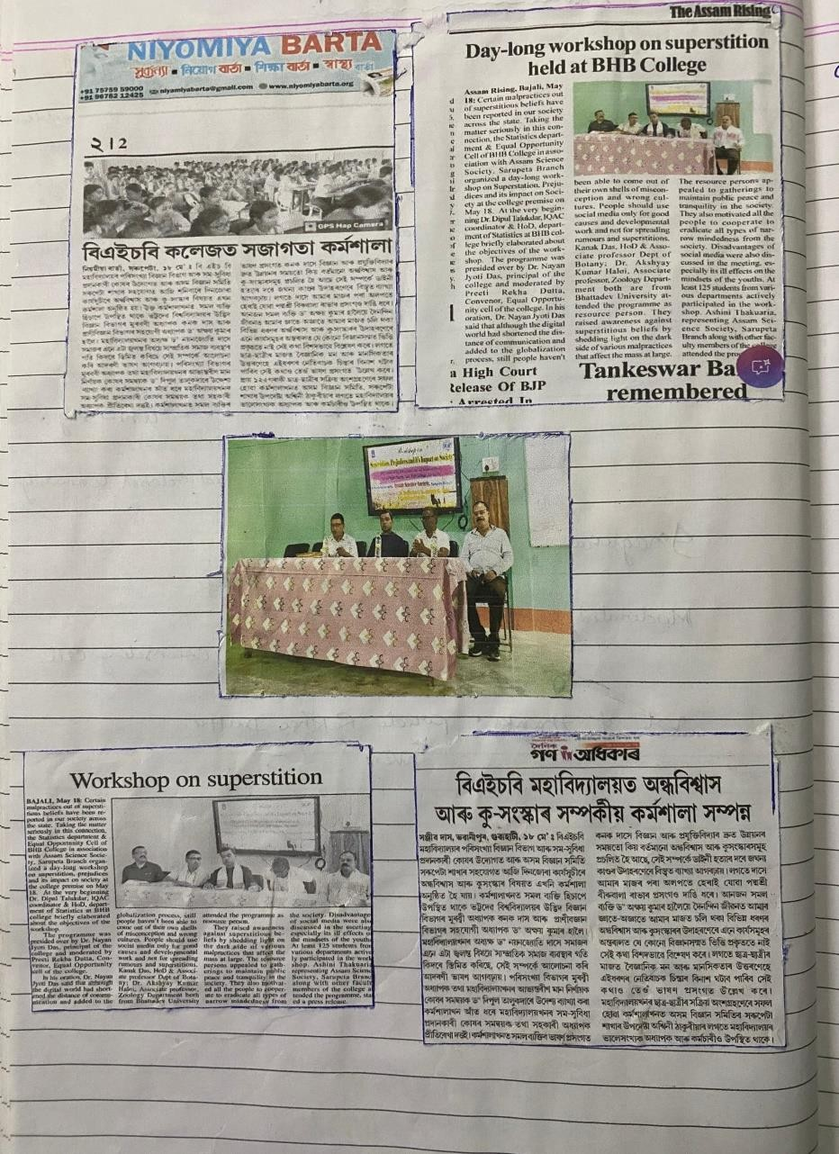
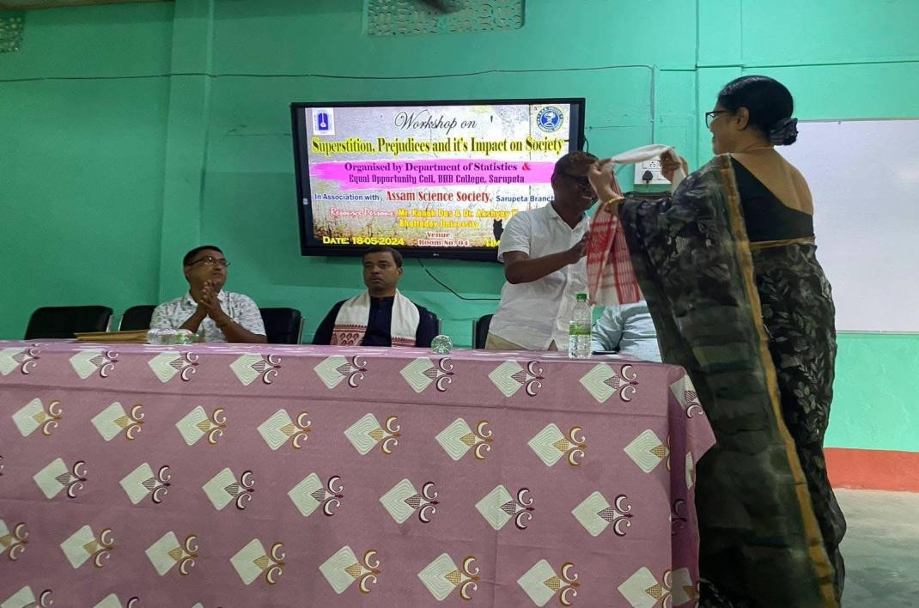
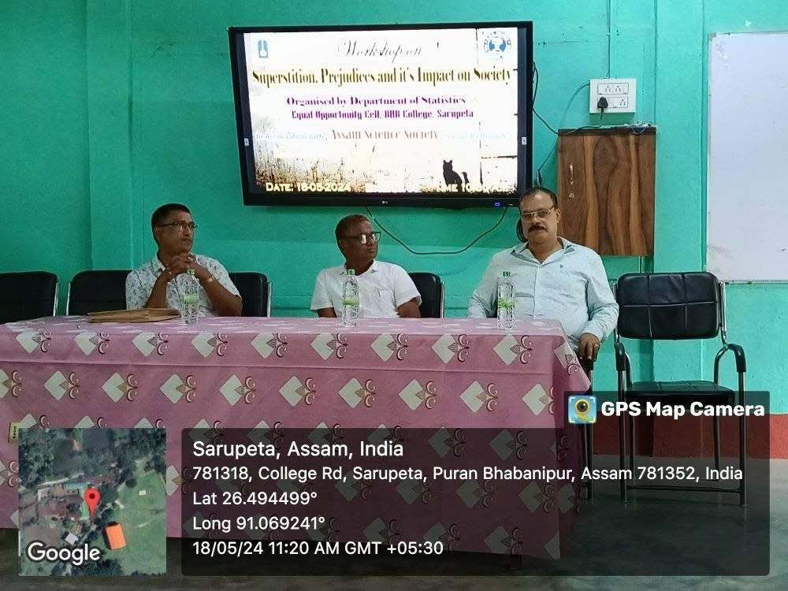

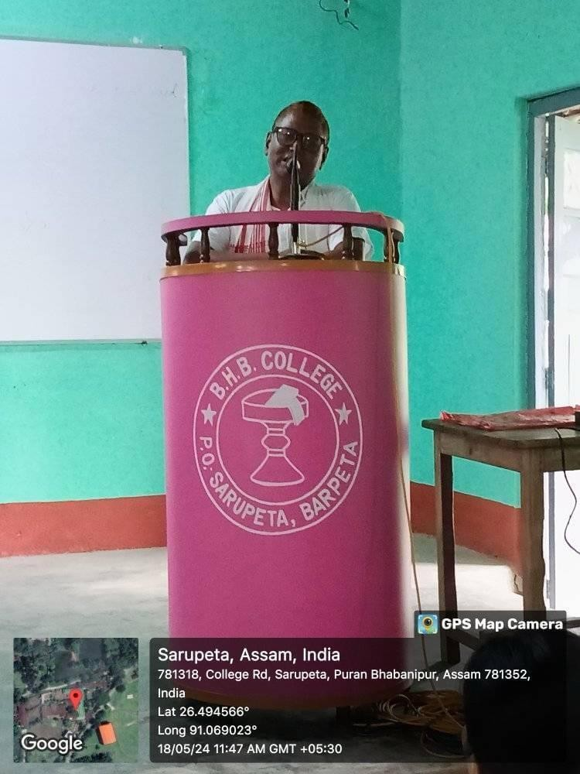
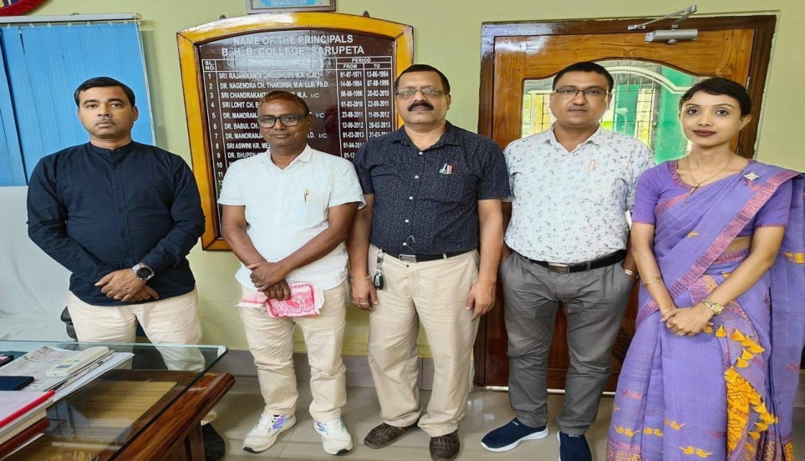

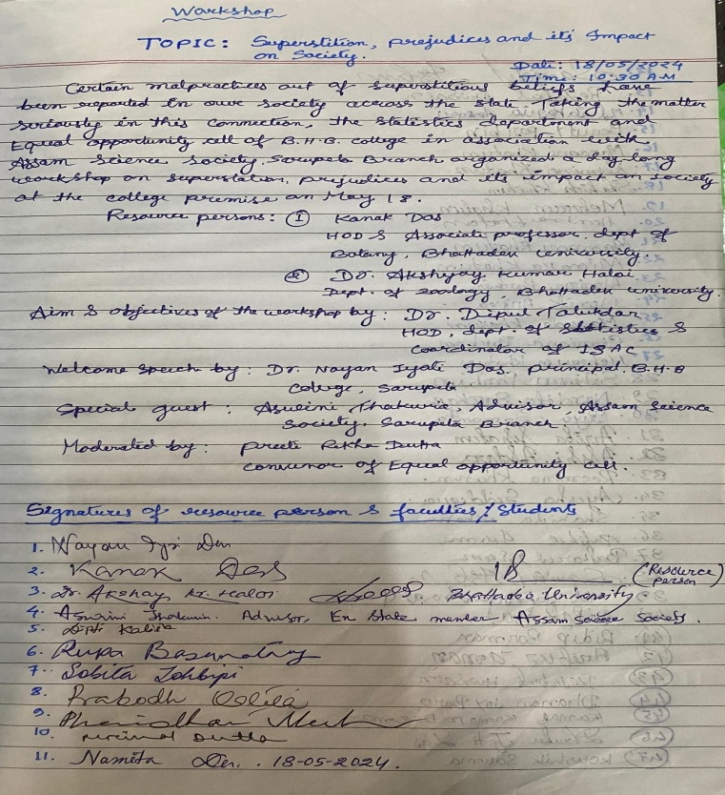

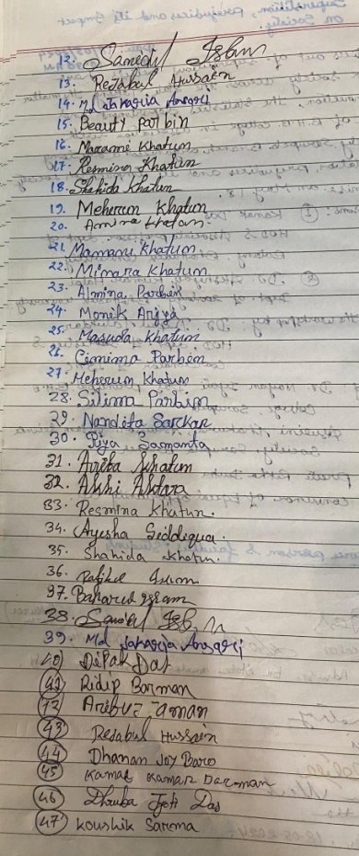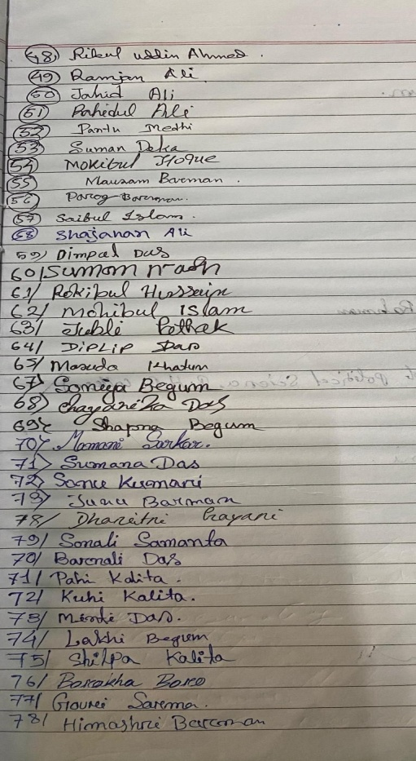
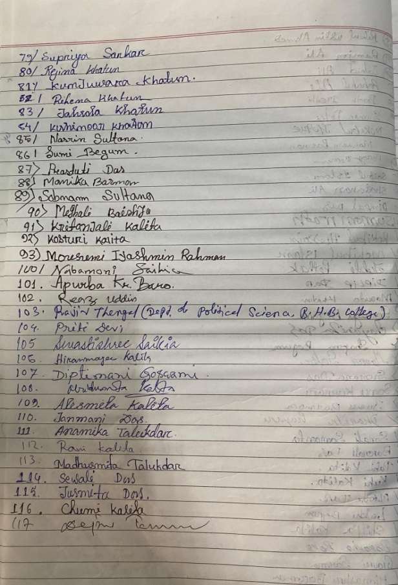
Yours faithfully

Principal,
B.H.B. College, Sarupeta

OFFICE OF THE PRINCIPAL
BHAWANIPUR HASTINAPUR BIJNI (B.H.B.) COLLEGE, SARUPETA
Accredited by NAAC (Third Cycle) with CGPA of 2.93 on Seven Point Scale at B++ Grade
P.O.: SARUPETA, DIST.: BARPETA
ASSAM, PIN – 781318
From - Website: www.bhbcollege.ac.in
Dr. Nayan Jyoti Das, M.A., Ph.D Email- principalbhbcollege18@gmail.com
Principal principalbhb2018@gmail.com
Ph. (03666) 299983, 9954934342
Memo. No.: BHBC/ Date: 17-11-2024

Departmental Seminar Report

Organized by: Department of Philosophy, B.H.B. College, Sarupeta
Seminar Theme: “Gandhi’s Philosophy of Gender and Equality”
Invited Resource Person: Dr. Purabi Talukdar, HoD, Dept. of Education and
Dr. Apurba Kr. Baro, Asst. Professor, Dept. of Bodo
Date: 10thMarch, 2024
Venue: Digital Seminar Hall.

The Department of Philosophy, B.H.B. College, Sarupeta has organized a departmental seminar event on 10th of March, 2024 at Digital Seminar Hall of new RCC Building on the theme “Gandhi’s Philosophy of Gender and Equality”. Dr. Purabi talukdar, HoD, Department of Education, BHB College and Dr. Apurba Kr. Baro, Assistant Professor, department of Bodo were invited as the resource person for the said seminar presentation. Mr. Mrinal Dutta, HoD, Department of Philosophy gave the welcome lecture and felicities a pulan gamusa to both the invited resource person, students and other faculty members present there. After the welcome session the speaker was offered to the resource person for brief lecture on “Gandhi’s Philosophy of Gender and Equality” to motivate the students. Later students were called for presentation one by one on the said topic. At the end as a discussion session both the resource person Dr. Talukdar and Dr. Baro gave valuable lecture on the emergence of Gandhi’s philosophy, ideas, thoughts and its implications on present society in a very short period of time. The resource person gave suggestions and motivates students to present the paper and share the ideas and findings near future. At the said seminar event total of 19 students have presented their paper. Along with the resource person and students total of 23 members were present. After all, Mr. Mrinal Dutta, HoD, Department of Philosophy has given the vote of thanks to the resource person, students and all other members and ended the programme.
Some glimpses of the event:
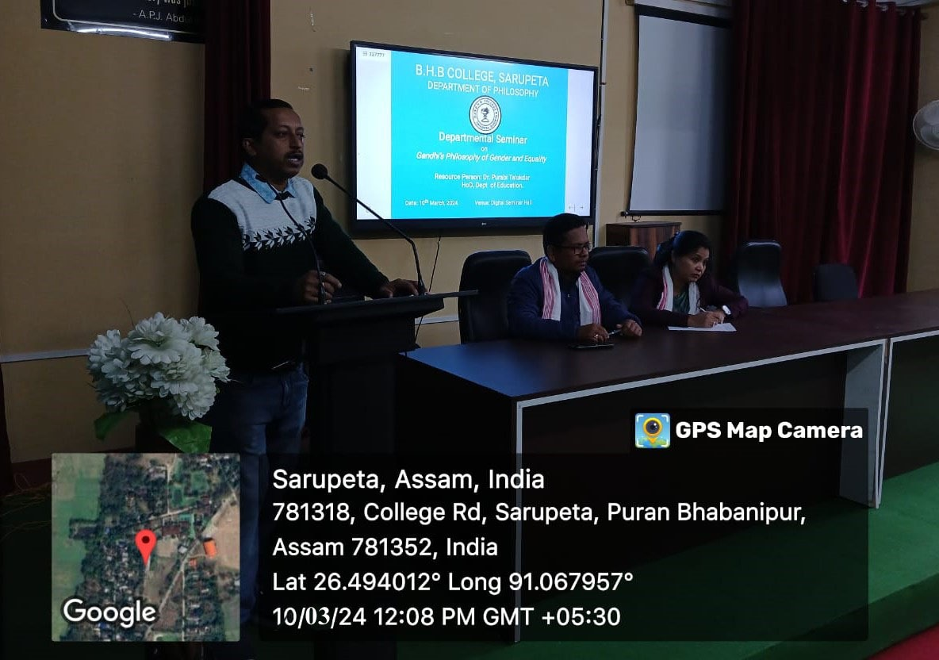
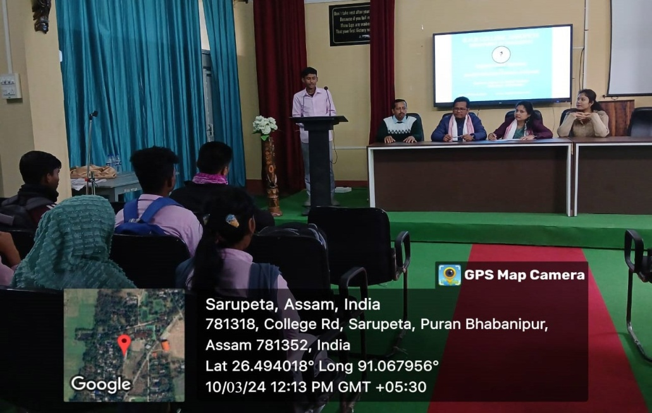
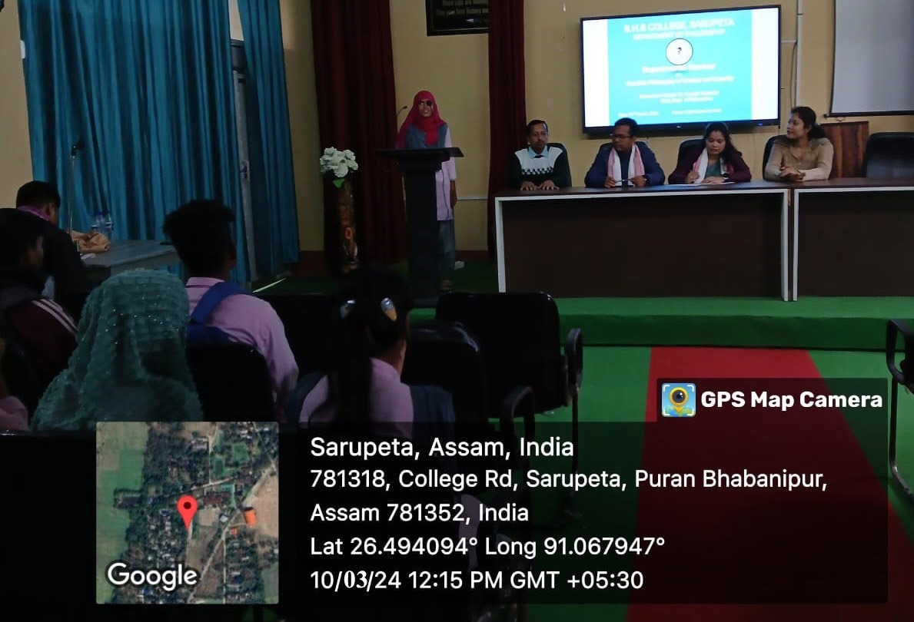

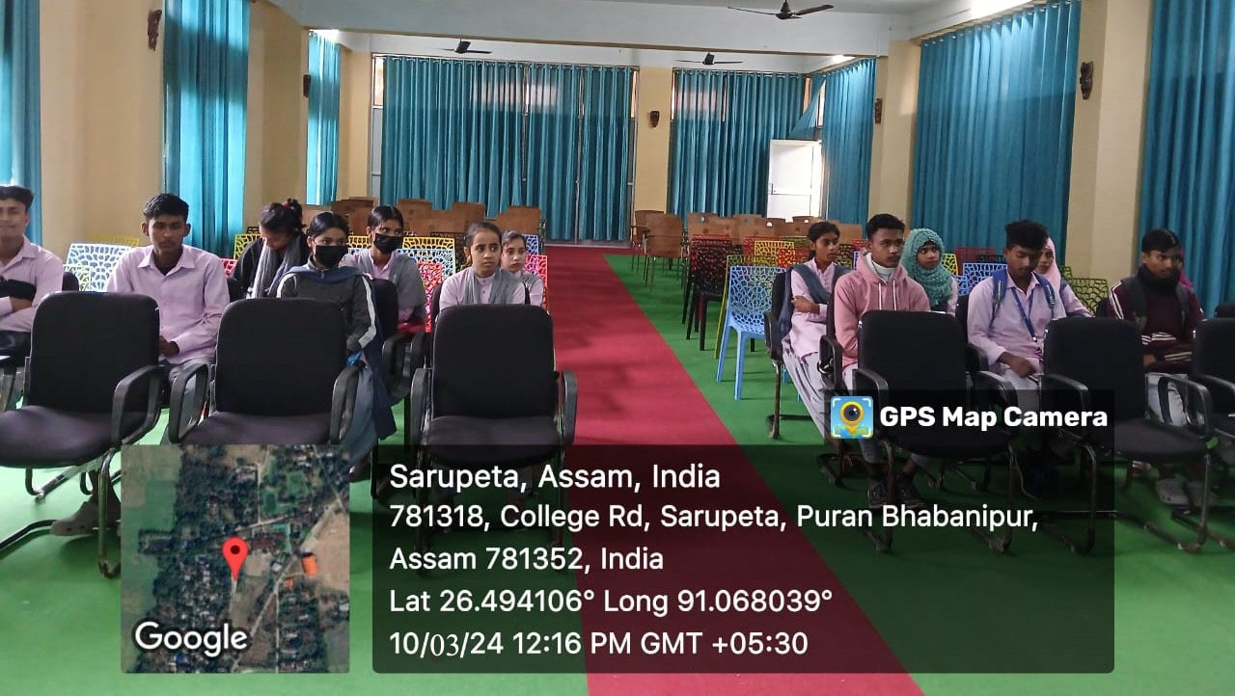
Signature of the members present:
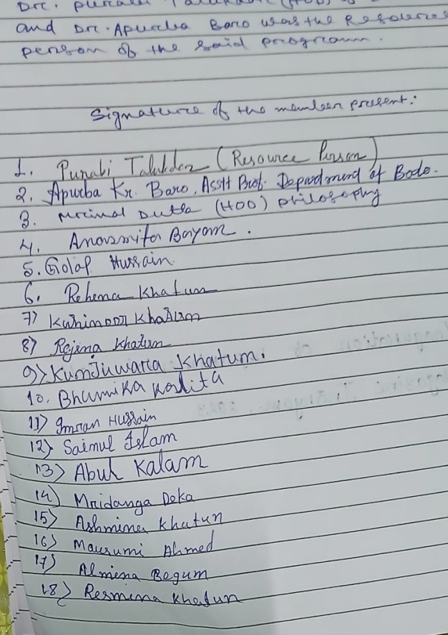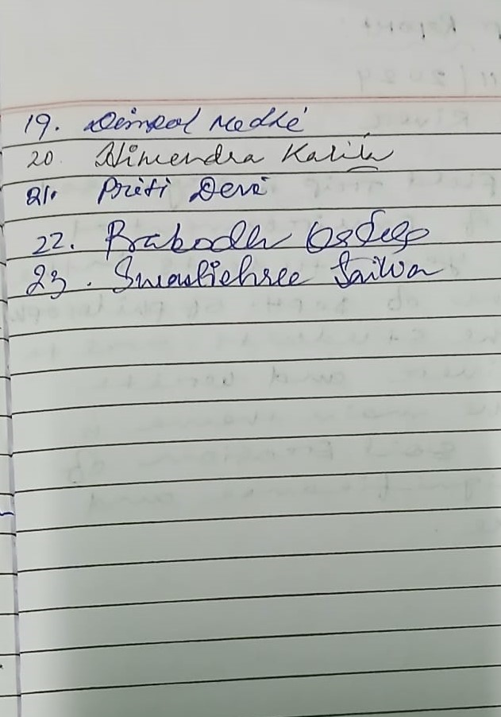

Yours faithfully
Principal,
B.H.B. College, Sarupeta

OFFICE OF THE PRINCIPAL
BHAWANIPUR HASTINAPUR BIJNI (B.H.B.) COLLEGE, SARUPETA
Accredited by NAAC (Third Cycle) with CGPA of 2.93 on Seven Point Scale at B++ Grade
P.O.: SARUPETA, DIST.: BARPETA
ASSAM, PIN – 781318
From - Website: www.bhbcollege.ac.in
Dr. Nayan Jyoti Das, M.A., Ph.D Email- principalbhbcollege18@gmail.com
Principal principalbhb2018@gmail.com
Ph. (03666) 299983, 9954934342
Memo. No.: BHBC/ Date: 17-11-2024

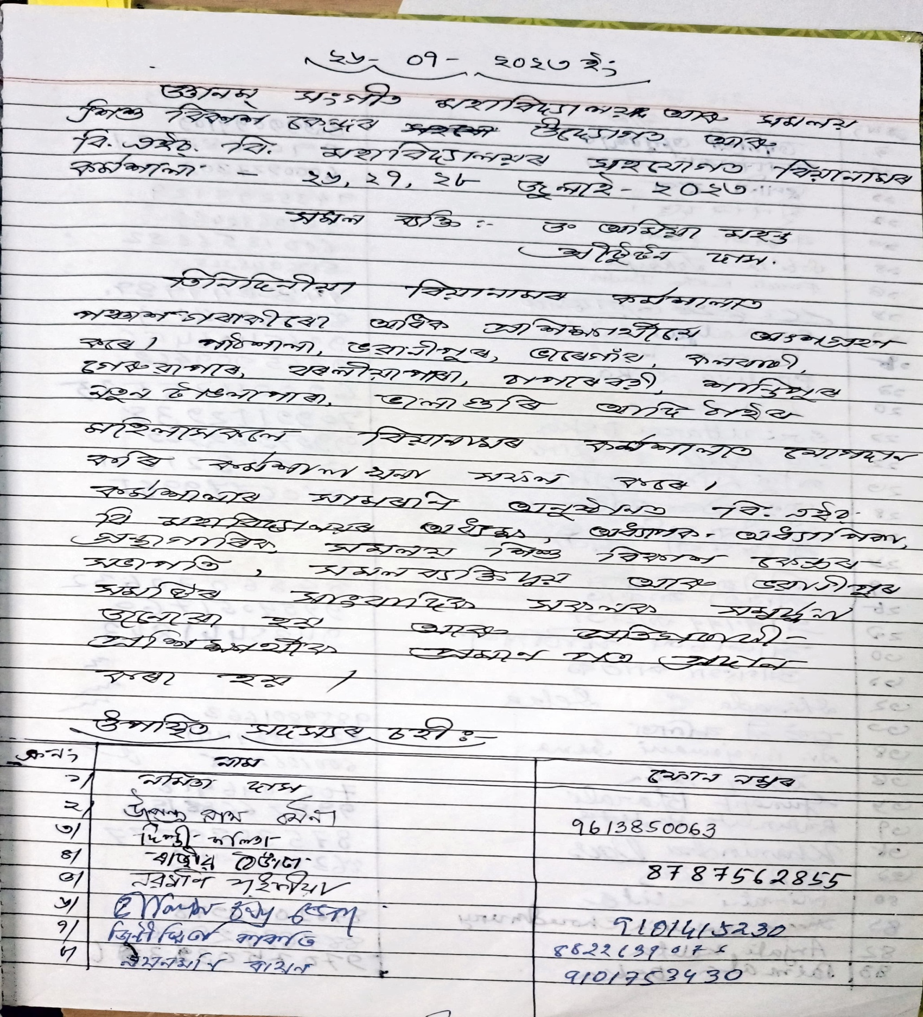

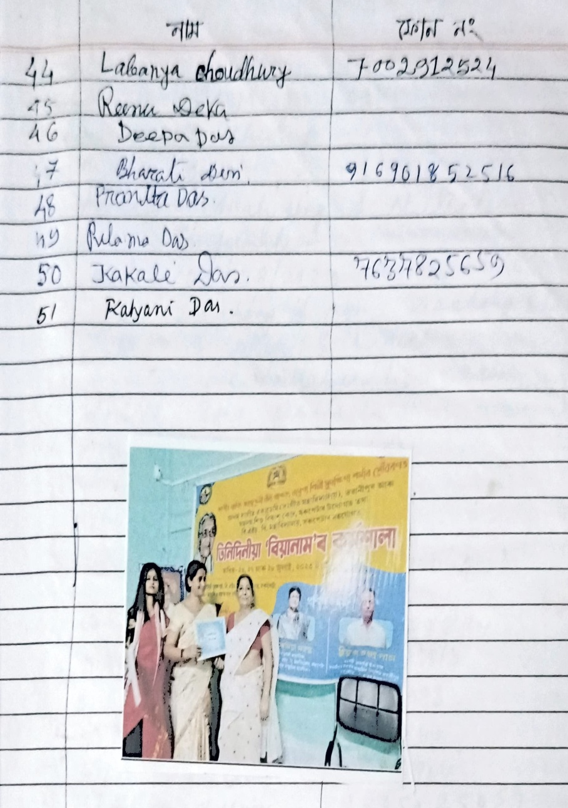
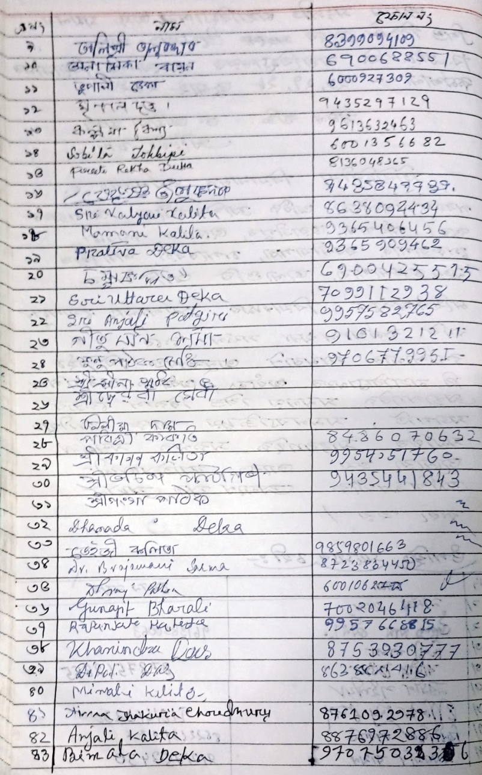

Yours faithfully
Principal,
B.H.B. College, Sarupeta

OFFICE OF THE PRINCIPAL
BHAWANIPUR HASTINAPUR BIJNI (B.H.B.) COLLEGE, SARUPETA
Accredited by NAAC (Third Cycle) with CGPA of 2.93 on Seven Point Scale at B++ Grade
P.O.: SARUPETA, DIST.: BARPETA
ASSAM, PIN – 781318
From - Website: www.bhbcollege.ac.in
Dr. Nayan Jyoti Das, M.A., Ph.D Email- principalbhbcollege18@gmail.com
Principal principalbhb2018@gmail.com
Ph. (03666) 299983, 9954934342
Memo. No.: BHBC/ Date: 17-11-2024

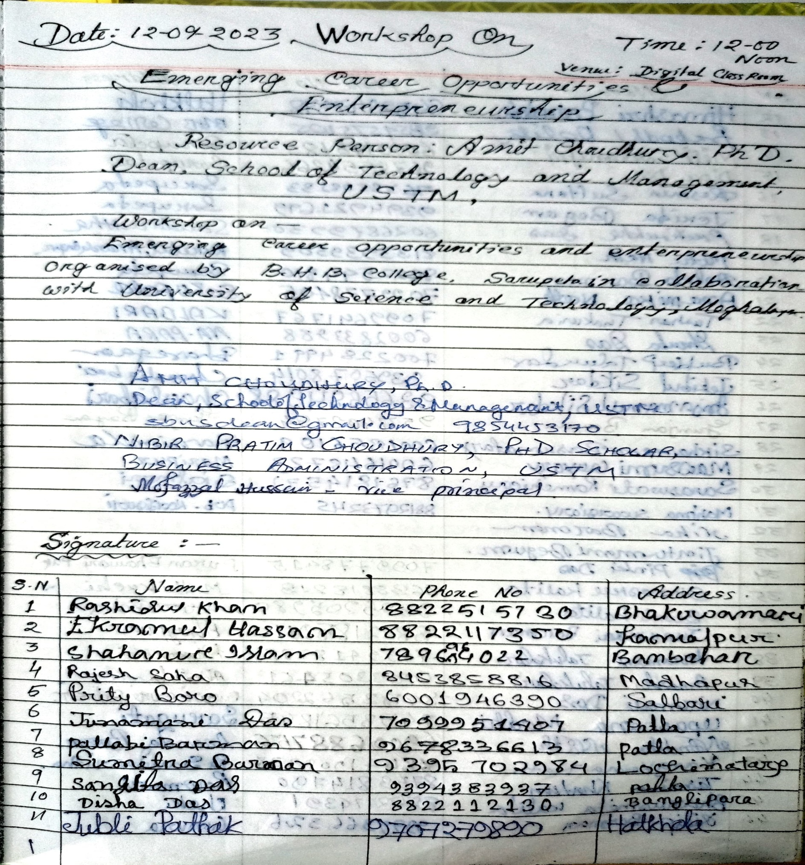

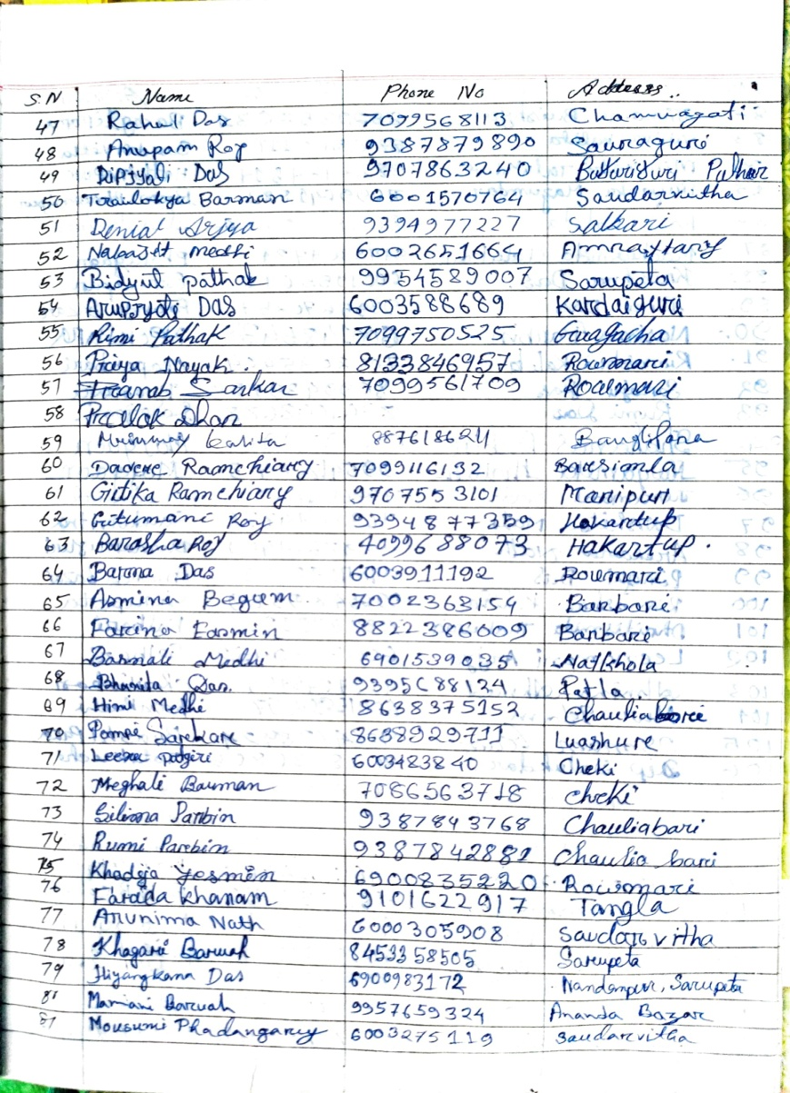
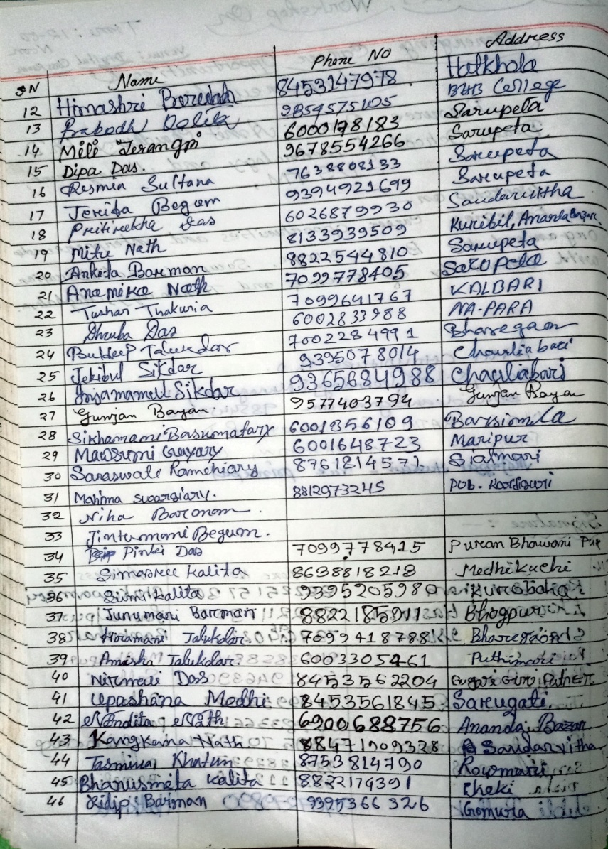

Yours faithfully
Principal,
B.H.B. College, Sarupeta

OFFICE OF THE PRINCIPAL
BHAWANIPUR HASTINAPUR BIJNI (B.H.B.) COLLEGE, SARUPETA
Accredited by NAAC (Third Cycle) with CGPA of 2.93 on Seven Point Scale at B++ Grade
P.O.: SARUPETA, DIST.: BARPETA
ASSAM, PIN – 781318
From - Website: www.bhbcollege.ac.in
Dr. Nayan Jyoti Das, M.A., Ph.D Email- principalbhbcollege18@gmail.com
Principal principalbhb2018@gmail.com
Ph. (03666) 299983, 9954934342
Memo. No.: BHBC/ Date: 17-11-2024

Report on One-Day Workshop on Organic Farming Organized by B.H.B. College, Sarupeta

Date: December 08/09/2023
Venue: Digital Seminar Hall, B.H.B. College, Sarupeta
Resource Person: Parikshit Chandra Bayan

On September 8, 2023, IQAC, B.H.B. College, Sarupeta, organized a one-day workshop on Organic Farming, aimed at raising awareness about sustainable agricultural practices and encouraging the adoption of organic farming techniques. The event took place at the Digital Seminar Hall of the college and was attended by students, faculty members, local farmers, and agriculture enthusiasts. The workshop was led by Parikshit Chandra Bayan, district agriculture officer and a a well-known expert in organic farming with years of experience in promoting environmentally-friendly farming methods. The workshop started promptly at 11:00 AM with an opening address by Dr. Dipti Kalita, HoD of Political Science, who emphasized the importance of organic farming in today's world. She explained how sustainable agricultural practices can help preserve soil health, reduce chemical dependency, and produce healthier food. The event attracted over 60 participants, including a mix of students, faculty, and local farmers from nearby villages.
Session Overview:
The resource person, Parikshit Chandra Bayan, delivered an insightful and comprehensive presentation on organic farming practices. His session was divided into several key areas of focus:
- Introduction to Organic Farming
- Soil Fertility and Management
- Pest and Weed Management
- Crop Diversification and Rotation
- Market Opportunities for Organic Products
After the presentation, an interactive session was held where participants could ask questions and share their experiences. Local farmers raised concerns about the initial challenges of transitioning to organic farming, such as the higher costs and the learning curve involved. Bayan patiently addressed these concerns, offering practical solutions, including government schemes, subsidies, and the potential for organic cooperatives.

The workshop was a great success, providing both theoretical knowledge and practical solutions for those interested in organic farming. It served as an important platform for students, farmers, and faculty to discuss the future of agriculture and the role of organic farming in achieving sustainability.

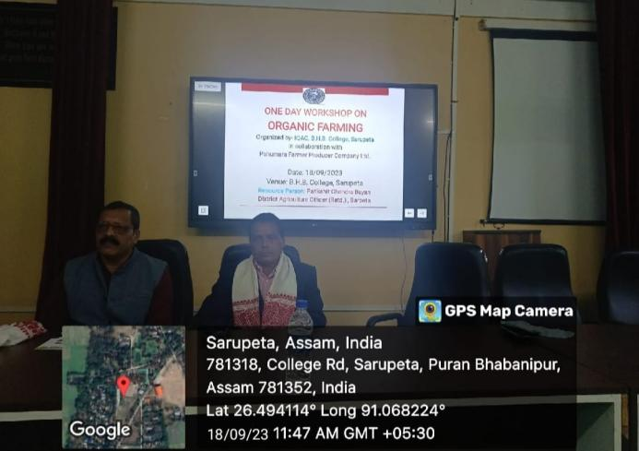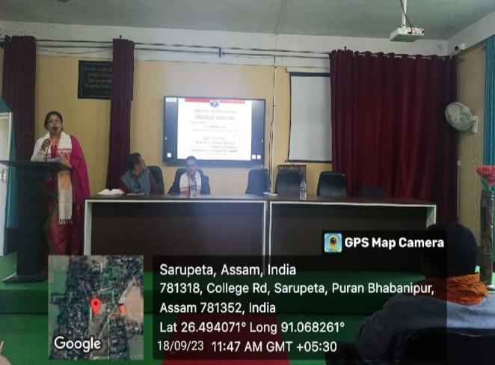

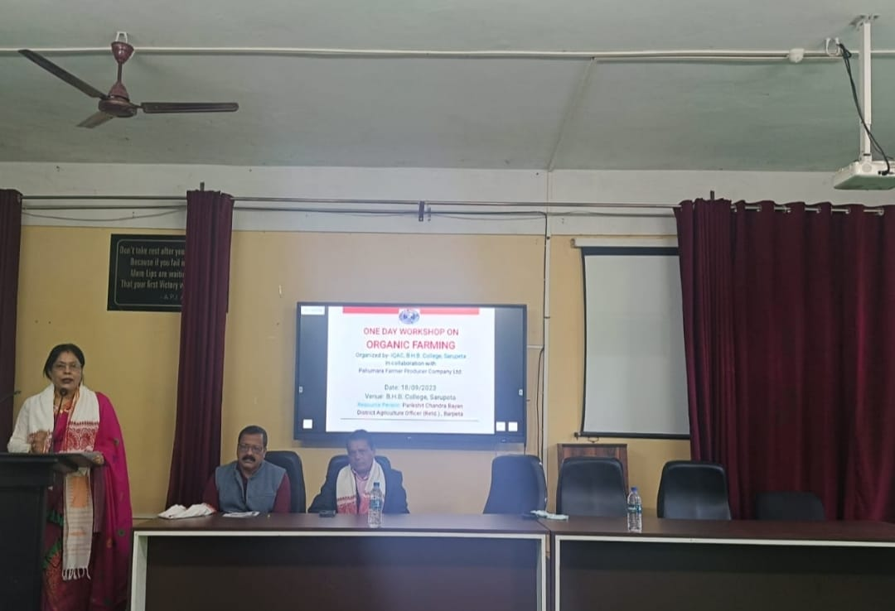
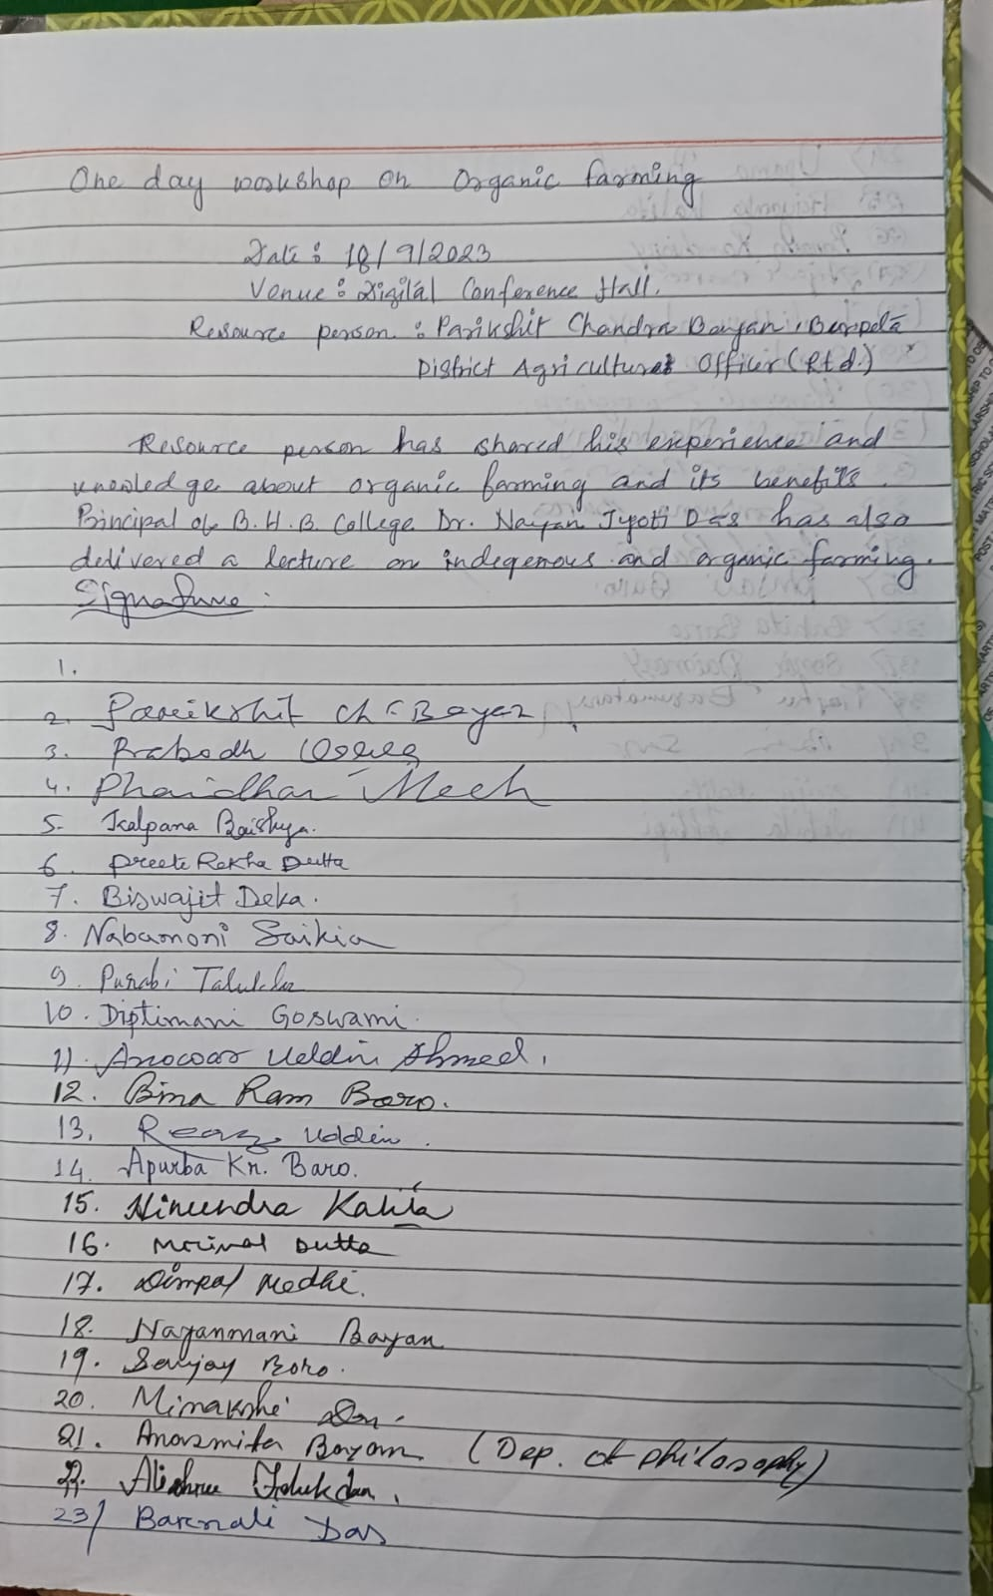

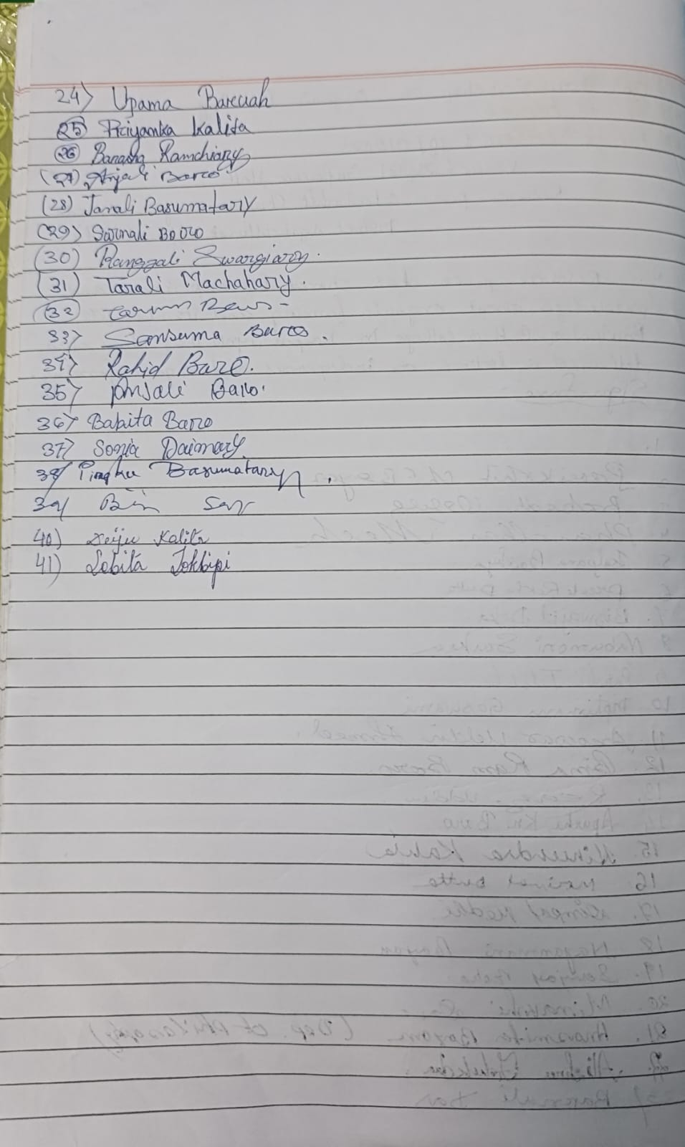

Yours faithfully
Principal,
B.H.B. College, Sarupeta

OFFICE OF THE PRINCIPAL
BHAWANIPUR HASTINAPUR BIJNI (B.H.B.) COLLEGE, SARUPETA
Accredited by NAAC (Third Cycle) with CGPA of 2.93 on Seven Point Scale at B++ Grade
P.O.: SARUPETA, DIST.: BARPETA
ASSAM, PIN – 781318
From - Website: www.bhbcollege.ac.in
Dr. Nayan Jyoti Das, M.A., Ph.D Email- principalbhbcollege18@gmail.com
Principal principalbhb2018@gmail.com
Ph. (03666) 299983, 9954934342
Memo. No.: BHBC/ Date: 17-11-2024

Workshop on ERP Software of Teaching and Non- Teaching Staff

Venue:-Digital Conference Hall Date: - 20/11/2023 Time: - 12.30 PM.
Resource Person: - Nabarun Mishra, Managing Partner, S.S. Technology, Guwahati, Assam.
A one day workshop on Enterprise resource Planning program for teaching and Non-teaching staff is organized by IQAC in collaboration with S.S.Technology, Guwahati, Assam, which is held on 20th Nov 2023 at digital conference hall. The resource person says how to implementing the Enterprise Resource Planning (ERC) system in rural area institutions, such as colleges, healthcare centers can brings different types of benefits, and improve Resource management such as-
- Help institutions efficiently manage limited resources, ensuring better allocation and reducing waste.
- Provides real-time visibility into resource utilization including funds, staff and materials.
At last Mishra says the ERP systems can transform rural area institutions and enhancing their efficiency and impact on the community.
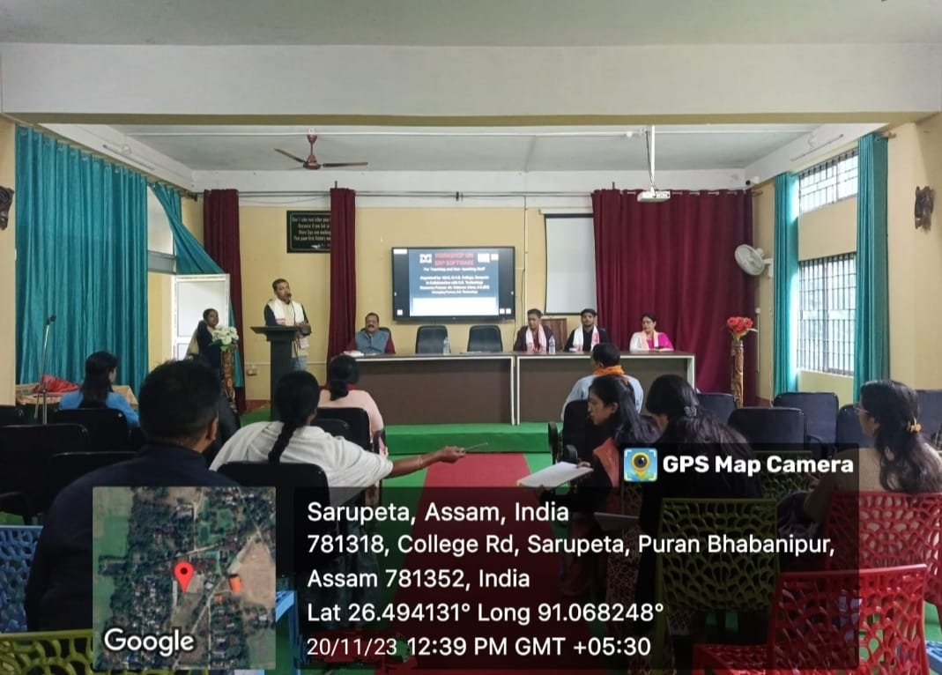
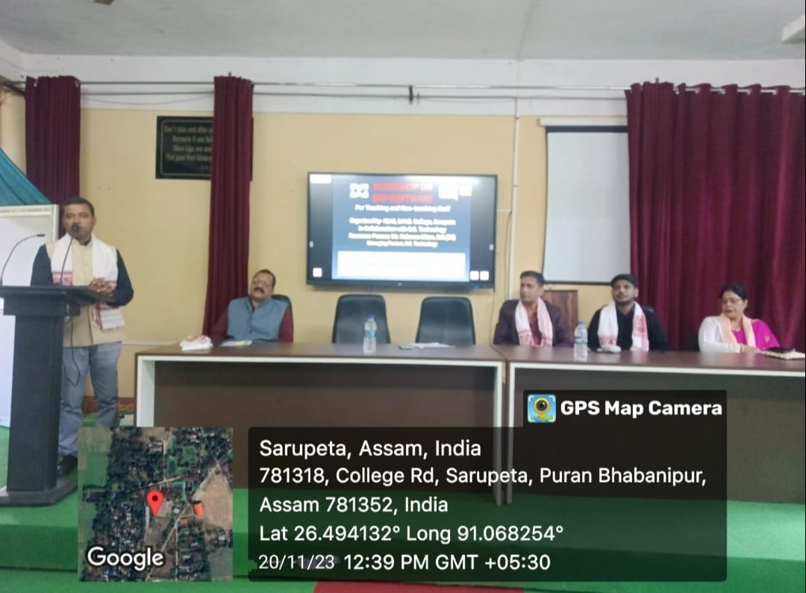

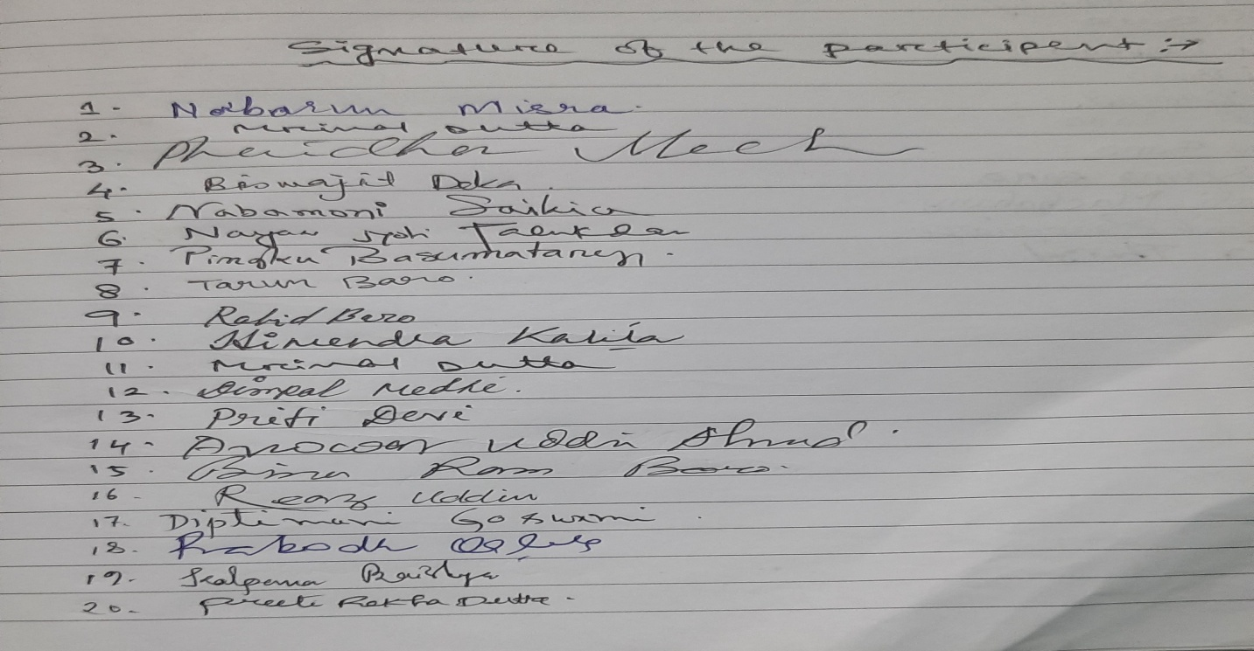
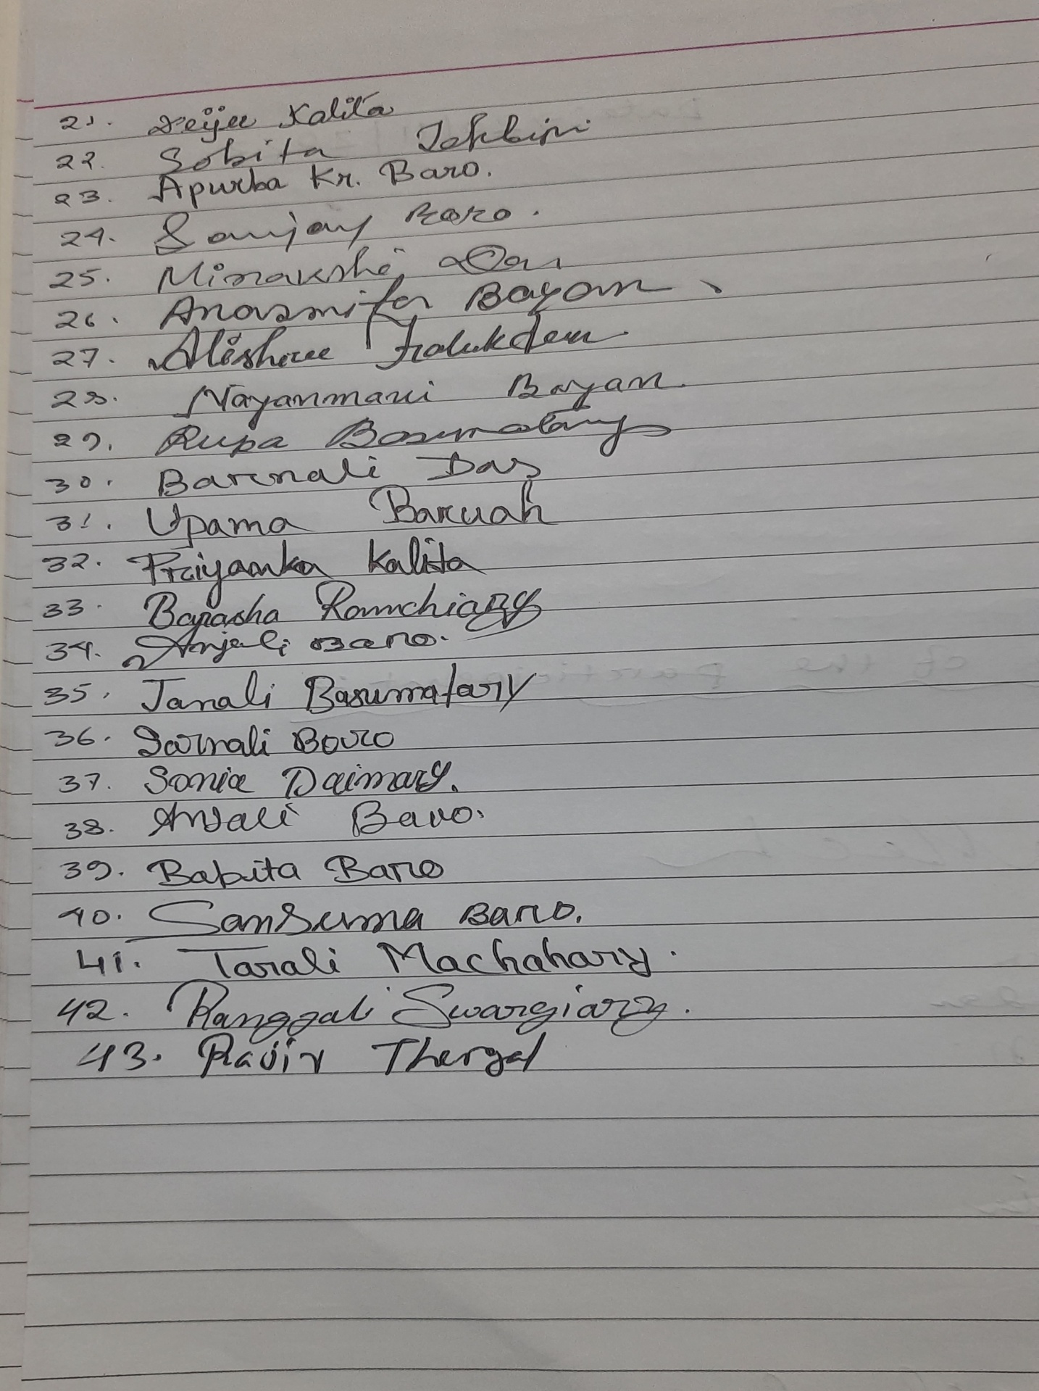

Yours faithfully
Principal,
B.H.B. College, Sarupeta

OFFICE OF THE PRINCIPAL
BHAWANIPUR HASTINAPUR BIJNI (B.H.B.) COLLEGE, SARUPETA
Accredited by NAAC (Third Cycle) with CGPA of 2.93 on Seven Point Scale at B++ Grade
P.O.: SARUPETA, DIST.: BARPETA
ASSAM, PIN – 781318
From - Website: www.bhbcollege.ac.in
Dr. Nayan Jyoti Das, M.A., Ph.D Email- principalbhbcollege18@gmail.com
Principal principalbhb2018@gmail.com
Ph. (03666) 299983, 9954934342
Memo. No.: BHBC/ Date: 17-11-2024

Webinar on Intellectual Property Rights

A webinar on Intellectual Property Rights was organized by the IQAC of B.H.B. College, Sarupeta on 23rd April, 2024 in the occasion of Intellectual Property Rights Day. The resource person of the webinar Dr. Pankaj Kalita, HoD, Dept. of Political Science, North Kamrup College, Baghmara delivers a valuable talk on IPR including patent, trademark, copyright, design and GI tag etc. The webinar was inaugurated by the honorable Principal of the college Dr. Nayan Jyoti Das with his inaugural speech. The webinar was hosted by the IQAC Coordinator Dr. Dipul Talukdar. 40 participants from the college had participated in the webinar and all the members have actively participated. Mrs. Deijee Kalita, Asstt. Coordinator IQAC had delivered the vote of thanks.
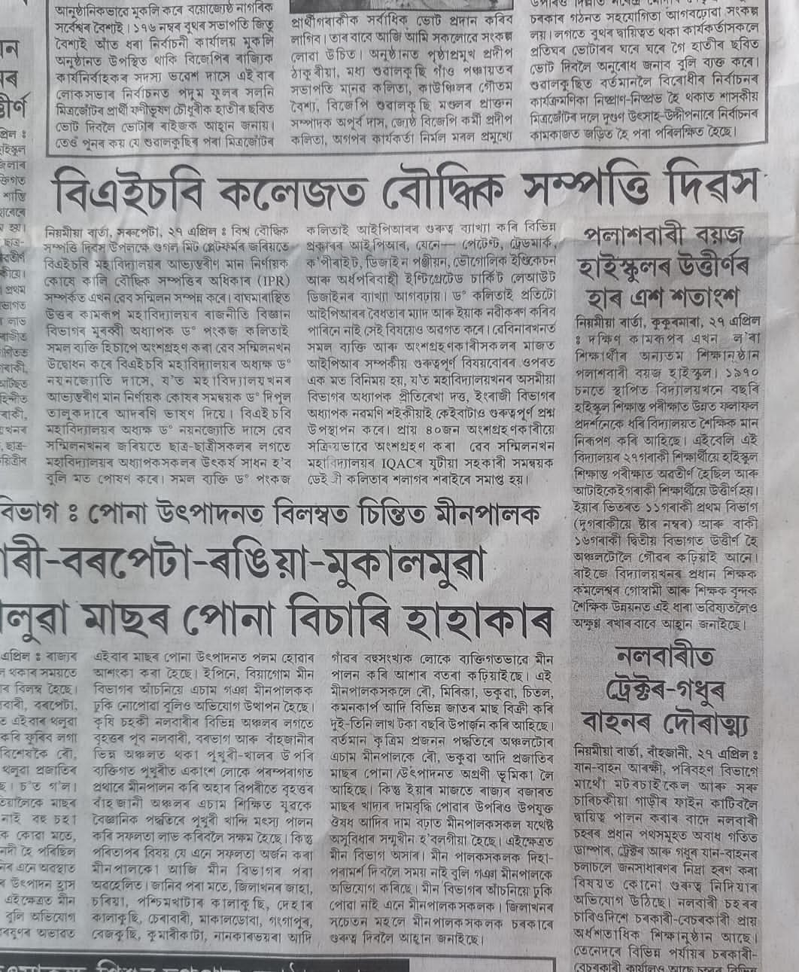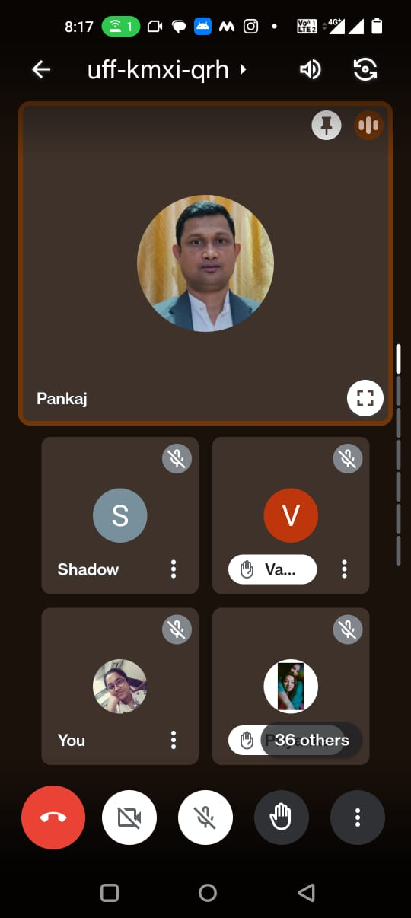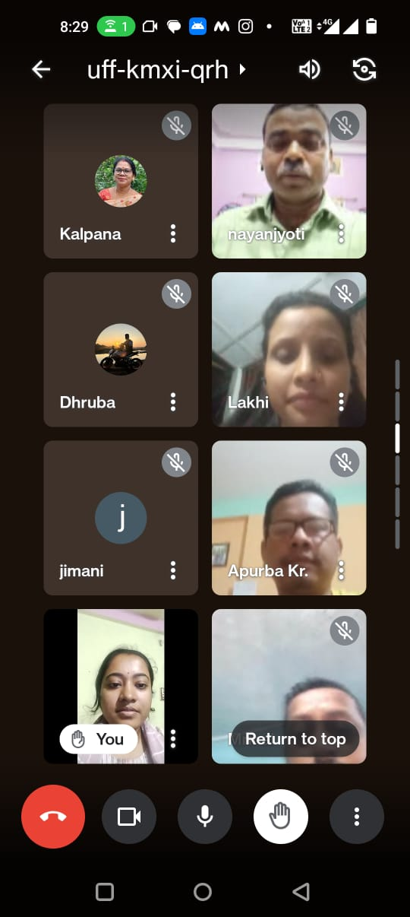

Yours faithfully
Principal,
B.H.B. College, Sarupeta

OFFICE OF THE PRINCIPAL
BHAWANIPUR HASTINAPUR BIJNI (B.H.B.) COLLEGE, SARUPETA
Accredited by NAAC (Third Cycle) with CGPA of 2.93 on Seven Point Scale at B++ Grade
P.O.: SARUPETA, DIST.: BARPETA
ASSAM, PIN – 781318
From - Website: www.bhbcollege.ac.in
Dr. Nayan Jyoti Das, M.A., Ph.D Email- principalbhbcollege18@gmail.com
Principal principalbhb2018@gmail.com
Ph. (03666) 299983, 9954934342
Memo. No.: BHBC/ Date: 17-11-2024

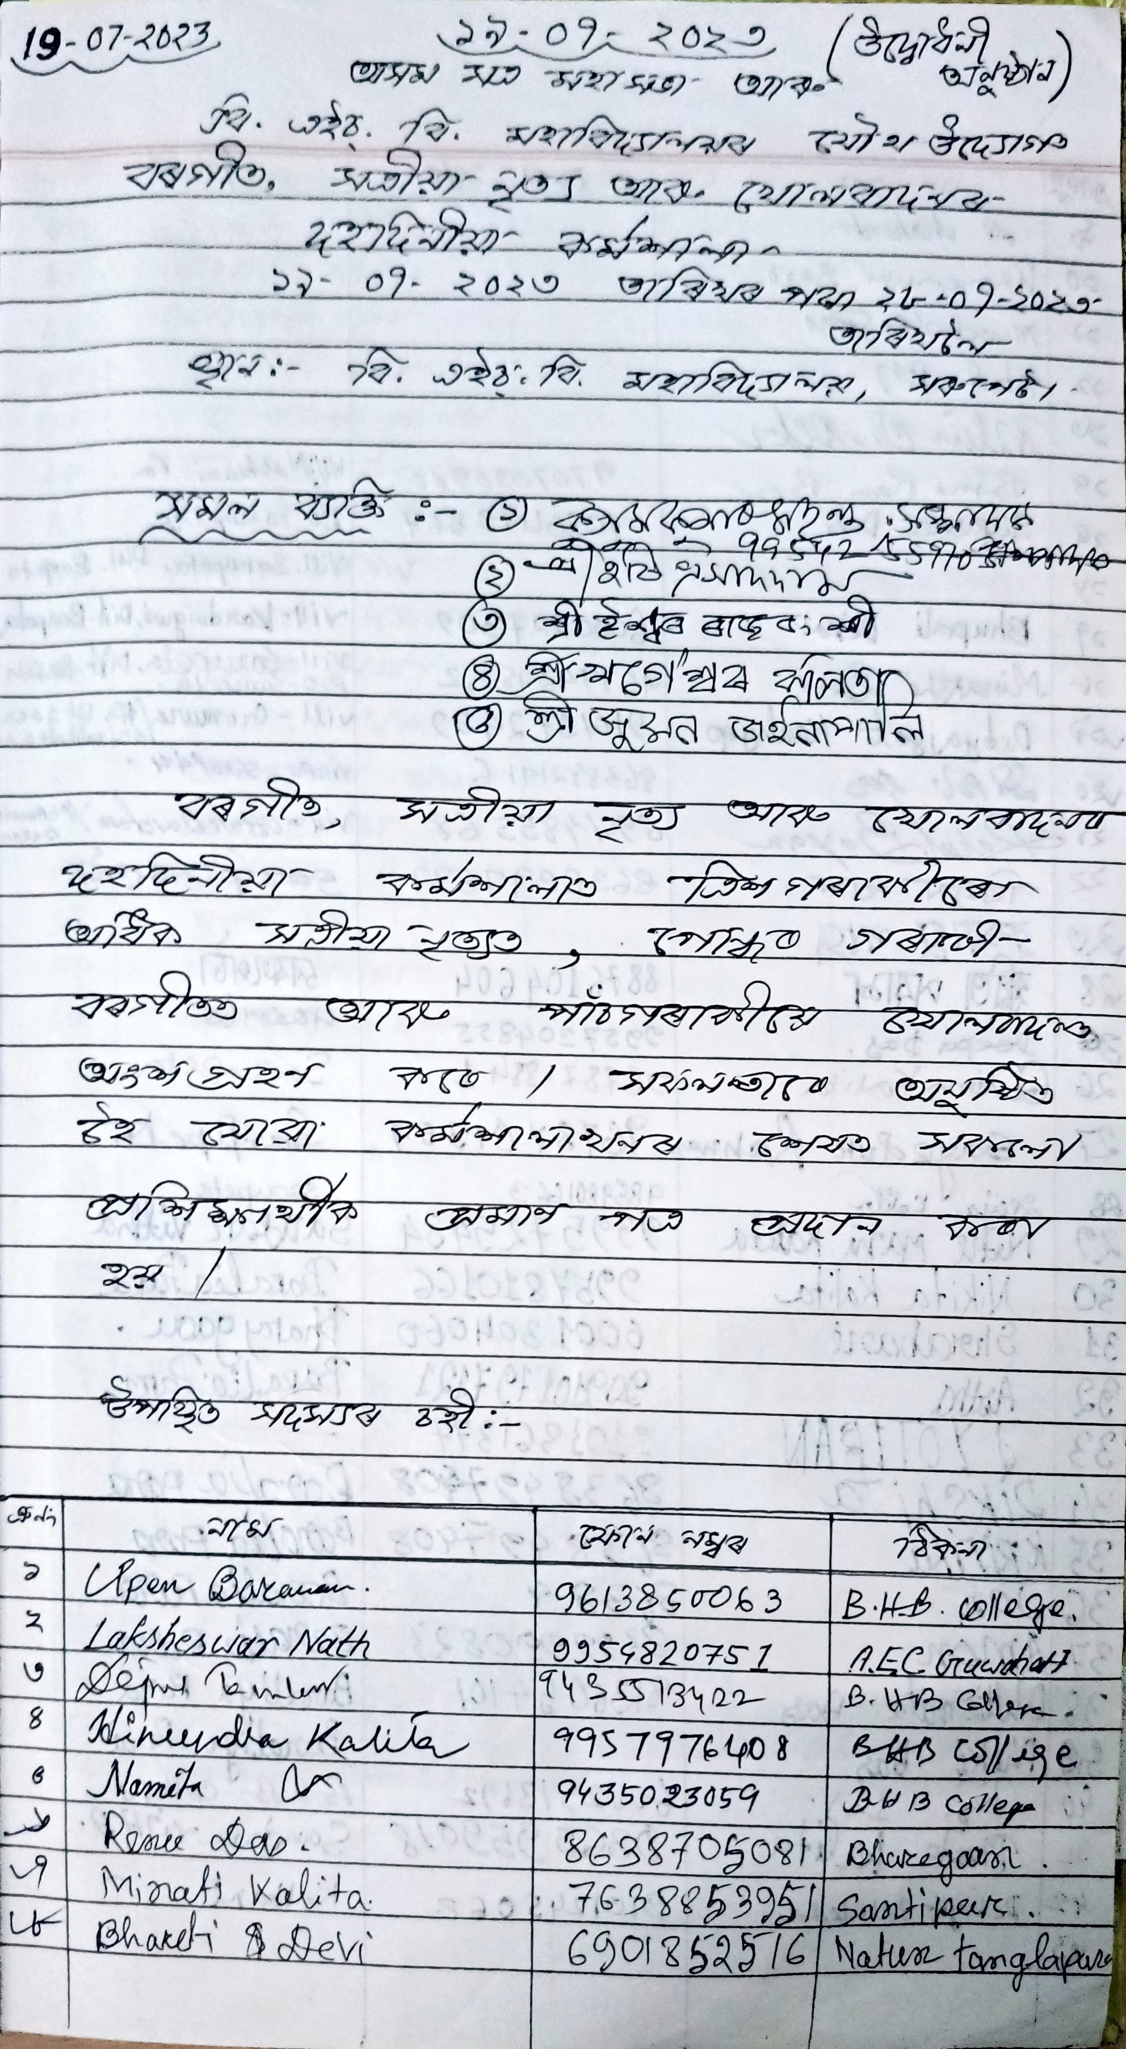

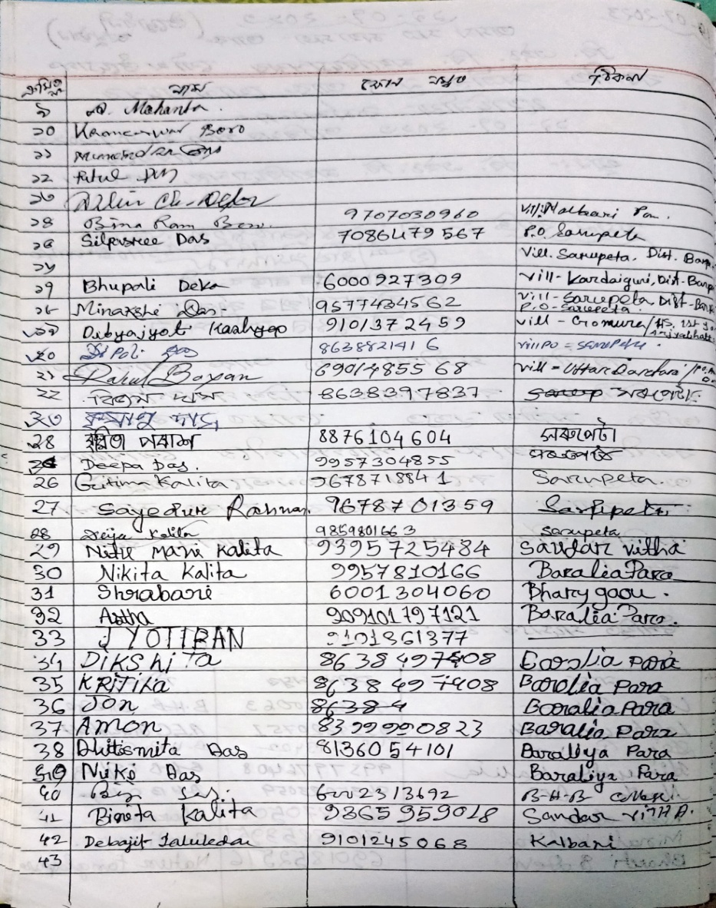
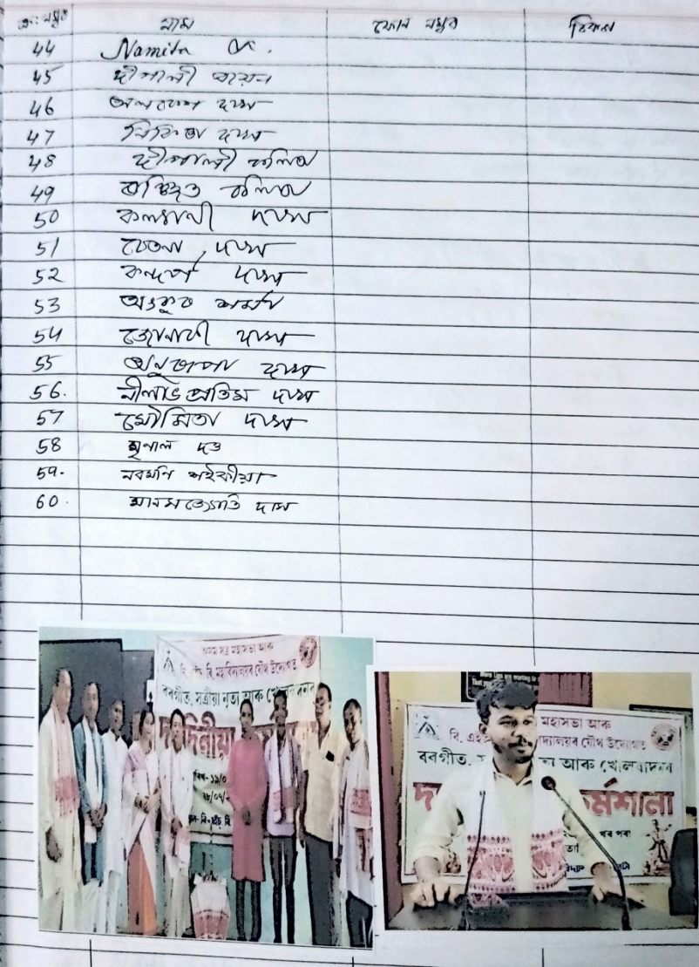

Yours faithfully
Principal,
B.H.B. College, Sarupeta

OFFICE OF THE PRINCIPAL
BHAWANIPUR HASTINAPUR BIJNI (B.H.B.) COLLEGE, SARUPETA
Accredited by NAAC (Third Cycle) with CGPA of 2.93 on Seven Point Scale at B++ Grade
P.O.: SARUPETA, DIST.: BARPETA
ASSAM, PIN – 781318
From - Website: www.bhbcollege.ac.in
Dr. Nayan Jyoti Das, M.A., Ph.D Email- principalbhbcollege18@gmail.com
Principal principalbhb2018@gmail.com
Ph. (03666) 299983, 9954934342
Memo. No.: BHBC/ Date: 17-11-2024

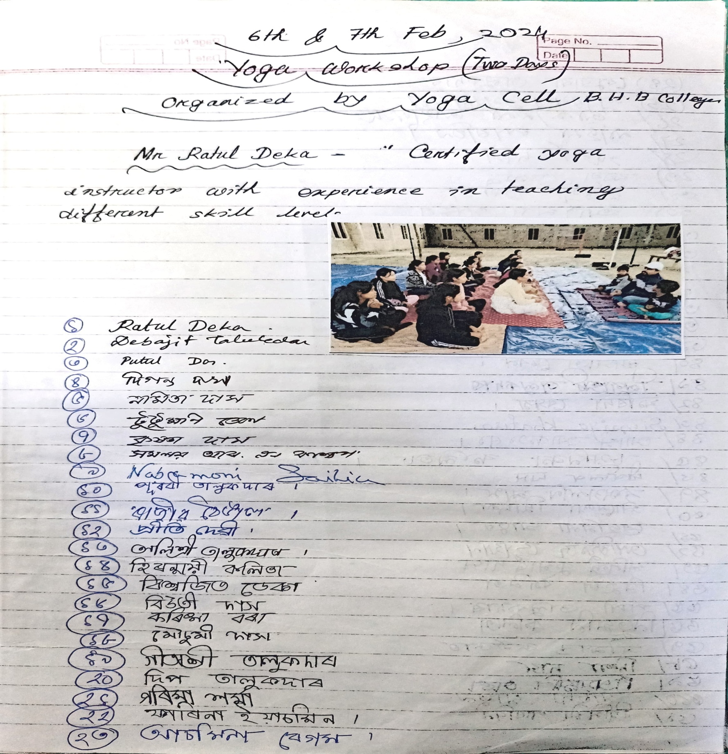

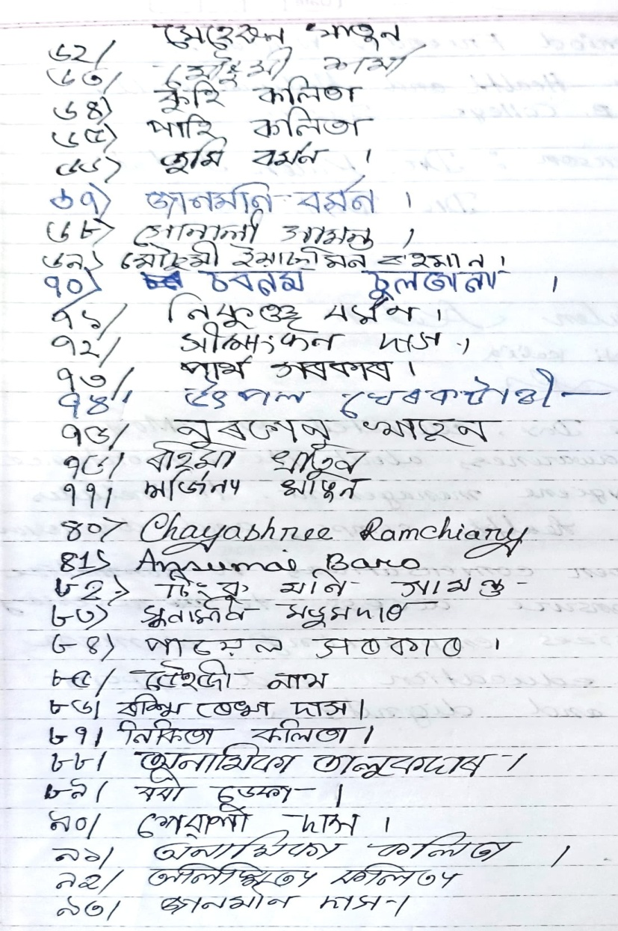
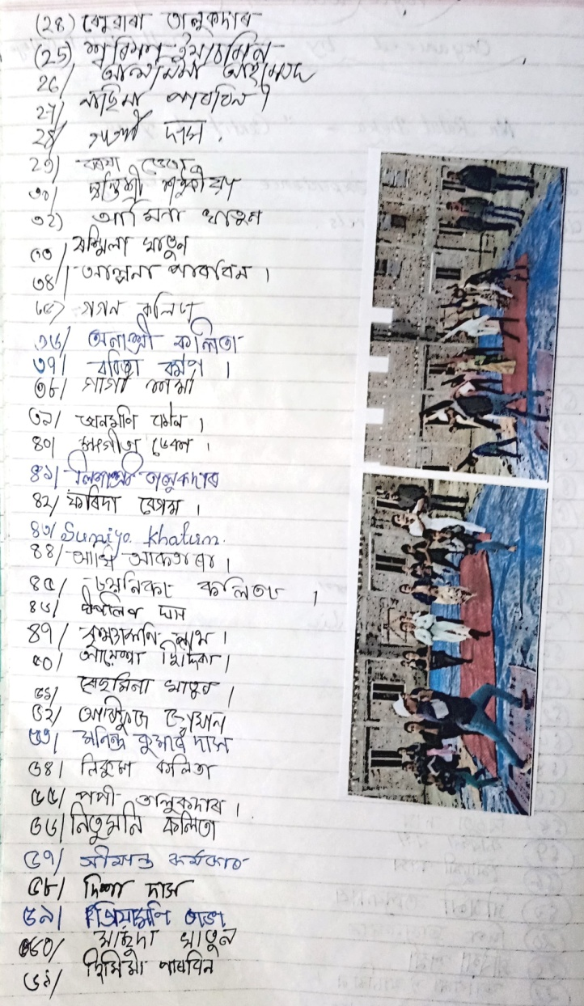

Yours faithfully
Principal,
B.H.B. College, Sarupeta

