The N.C.C. Unit, B.H.B. College has celebrated the 71th NCC Day with a big zeal and enthusiasm on 24 November, 2019. According to the programme N.C.C. flag hoisted, NCC song has been sung and planted tree. As far the direction of 7 Assam Bn. N.C.C., Dhubri a guest, ex-army and prominent social activist Praneswar Baishya invited to hoist flag and for tree plantation programme. NCC-C.T.O. Rajiv Thengal inaugurated the programme and Ex-C.T.O. of NCC Namita Das and social activist Praneswar Baishya delivered a speech to the cadets motivating them to be dedicated and committed to NCC motto and NCC activities. On this auspicious day a cadet Sachin Daimary selected the best cadet of the year for his performance and active participation in NCC activities. An English-Assamese dictionary has been presented to Sachin Daimary by NCC Unit BHB College. Below some pictures are given to highlight the NCC-Day celebration-
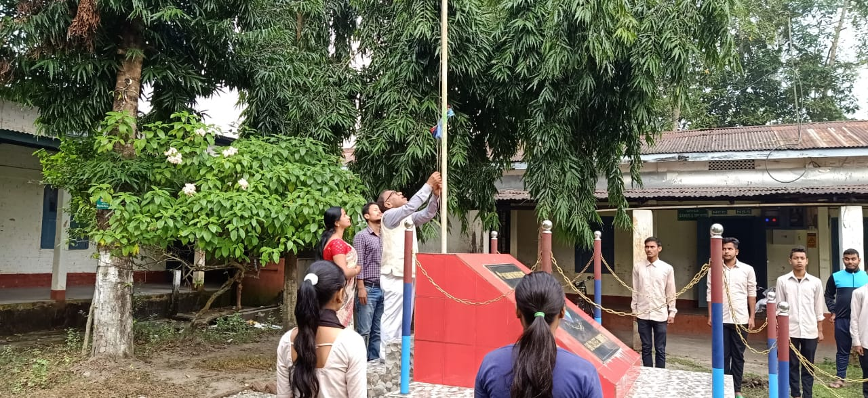
Flag Hoisted by Ex-Army Praneswar Baishya
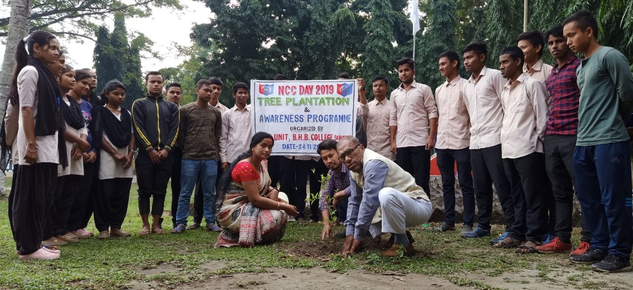
Tree Plantation
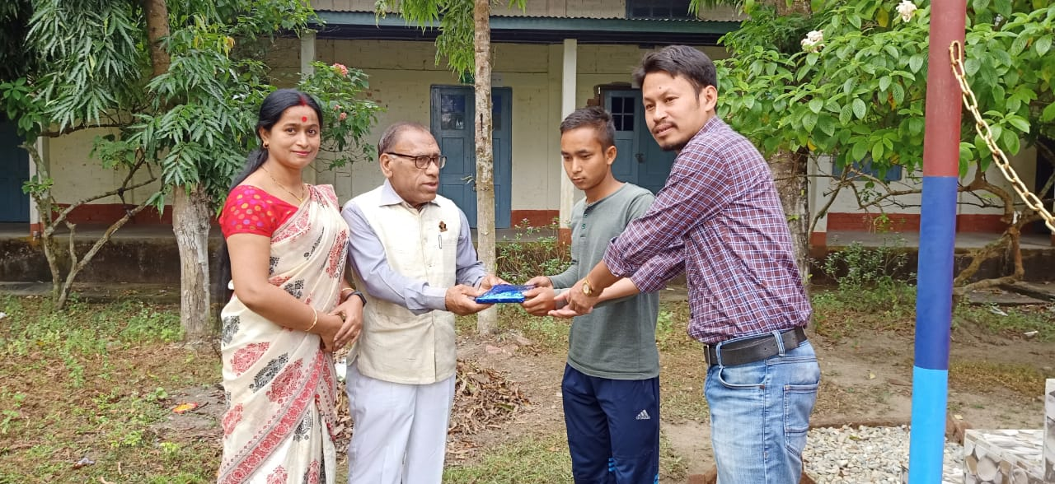
Best cadet award to Sachin Daimary

