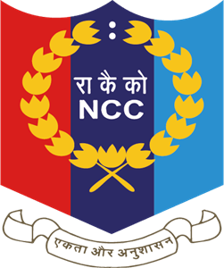

Profile of NCC
B.H.B College, Sarupeta
7 Assam Bn NCC, Dhubri
60 Assam Bn NCC,Guwahati

Introduction:

The NCC is the Indian military cadet corps with it's headquartering at New Delhi. It is open to school and college students on voluntary basis. NCC is a Tri-service organization, comprising the Army Navy and air force, engaged in grooming the youth of the country into disciplined and patriotic citizen. It is voluntary organization which recruits cadets from high school, colleges and universities all over India.NCC inculcates in the youth a sense of nationalism and secular outlook that contributes towards the building of nation. It also provides a platform for individual upliftment through the process of channelizing the energy of the youth in constructive pursuit. Besides giving thrill and excitement, NCC promotes camaraderie and resilience and honest cultural skills to preserve the cultural traditions and values of the society. It helps the youth to realize the intimate relationship between man and community and nature and their inter-dependability. The Present Cadet strength of 7 Assam Bn NCC unit of the college is 61 Cadet & 60 Assam Girl’s Bn NCC unit of the college is 53 Cadet.
Year of establishment of NCC Unit:

- The NCC Unit of BHB College was started in the year 2002 under 7 Assam Bn NCC, Dhubri.

- The NCC Unit of BHB College was started in the year 2022 under 60 Assam Girl’s Bn NCC, Guwahati.

Objectives of NCC:

The main objectives of National Cadet Corps (NCC) are:

- To develop character, comradeship, discipline, leadership, secular outlook, spirit of adventure and ideals of selfless service amongst the youth of the country.

- To create a human resource of organized, trained and motivated youth t provides leadership in all walks of life and is always available for the service of the Nation.

- To provide a suitable environment to motivate the youth to take up a carrier in the Armed Forces.

The college, since its inception, has given adequate importance to fulfil its social responsibility by opening opportunities for different extra-curricular and extension activities. Extension activities are now an integral part of education, which underline the importance of community services and inculcate values and Commitment to society. As part of the project, the college has been running an NCC unit since its establishment, the NCC unit of the College has been functioning very actively and has brought achievement and glory to the college.

Activities of NCC:

- From 2022 the unit also observed World Rivers Day Celebration 30 September.

- The NCC Cadets of the college perform various drill and training programme in and outside the state. Among their regular activities, they take part in the Republic Day and Independence Day Parade Programme of the District Administration every year. Besides, some other public institute or organization invites the NCC units for parade performance.

- Within the college also, the BHB College NCC units organized impressive parades program on special occasions of the college such as the opening of Annual Sports Festival etc.

- On the occasion of the Gauhati University Inter College Foot Ball Tournament held in BH College on 24-24 Jan 2014, a highly impressive parade program was performed by the college NCC unit which mesmerized the hundreds of the students and common people.

- From 2014 the Unit also observed International Yoga Day on 21st June.

- This year the unit observed Swachh Bharat Abhiyan on 28 September.

- The unit also published a wall magazine every year.

AIM OF NCC

The ‘Aims’ of the NCC laid out in 1988 have stood the test of time and continue to meet the requirements expected of it in the current socio–economic scenario of the country. The NCC aims at developing character, comradeship, discipline, a secular outlook, the spirit of adventure and ideals of selfless service amongst young citizens. Further, it aims at creating a pool of organized, trained and motivated youth with leadership qualities in all walks of life, who will serve the Nation regardless of which career they choose. Needless to say, the NCC also provides an environment conducive to motivating young Indians to join the armed forces.
* To develop good qualities like good character, commandership, discipline, leadership, secular outlook, spirit of adventure, sportsman spirit, and the ideals of selfless service amongst the youth of the country.
* To create a human resource of organized, trained and motivate youth to provide leadership in all walks of life and always available for the service of the nation.
* To provide a suitable environment to motivate the youth to take up a career in the Armed Forces like Army, Navy, Air Force and other paramilitary forces.
MOTTO OF NCC

The motto of NCC is “Unity and Discipline” which was adopted on 23 Des.1957. In living up to its motto, the NCC strive to be and is one of the greatest cohesive forces of the nation, bringing together the youth hailing from different parts of the country and moulding them into united, secular and disciplined citizens of the nation.
NCC PLEDGE

We the cadet of the national cadet corps, do solemnly pledge that we shall always uphold the unity of India. We resolve to be disciplined and responsible citizen of our nation. We shall undertake positive community service in the spirit of selflessness and concern for our fellow beings.
NCC FLAG

The NCC flag for various units of the NCC was
first introduced in 1951. The flag was of same
pattern, colour & size as was used by various
regiments of the Army. The only difference was
that it had the NCC badge & unit designation
placed in the centre. In 1954 the existing tricolour flag was introduced. The three colours in the flag depict the three services of the Corps, red for the Army, deep blue for the Navy & light blue for the Air Force. The letters NCC & the NCC crest in gold in the middle of the flag encircled by a wreath of lotus (17 Directorates), give the flag a colourful look & a distinct identity.

Ranks in Senior Division NCC
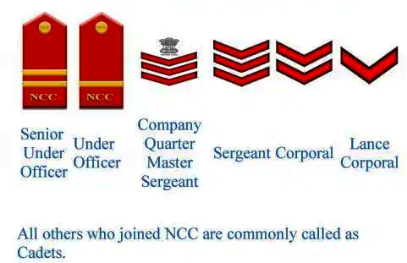

- RANKS OF ARMY WING NCC
- SUO: Senior Under Officer
- JUO: Junior Under Officer
- CQMS: Company Quarter Master Sergeant
- SGT: Sergeant
- CPL: Corporal
- LCPL: Lance Corporal
- CDT: Cadet

AIM OF CAMPS

- To impact collective training in the subject as per laid down syllabus to the senior wing cadet and develop physical and mental robustness in cadets.
- To develop qualities of leadership, self-discipline and ideals of selfless service benefiting the society.
- To expose cadets to camp living and foster spirit of comradeship and e-spirit-de-corps.
- To foster competitive spirit and sportsmanship.

ACTIVITIES RUN BY NCC UNIT

NCC unit of our college has undertaken various activities regarding community development every year such as:
- Blood Donation
- Aids Awareness
- Cleanliness Program
- College Campus Beautification
- International Yoga Day
- NCC Day
- Social Programs
- Tree Plantation
- Volunteering

NCC SONG

Ham sab Bhartiya Hain,
Ham Sab Bhartiya Hain.
Apni Manzil Ek Hai,
Ha, Ha, Ha, Ek Hai,
Ho, Ho, Ho, Ek Hai,
Ham Sab Bhartiya Hain.

Kashmir ki Dharti Rani Hai,
Sartaj Himalaya Hai,
Saadiyon Se Hamne Isko Apne Khoon
Se Pala Hai,
Desh ki Raksha ki Khatir Ham Shamshir
Utha Lenge,
Ham Shamshir Utha Lenge.

Bikhre-Bikhre Taare Hain Hum Lekin
Jhilmil Ek Hai,
Ha, Ha, Ha, Ek Hai,
Ho, Ho, Ho, Ek Hai,
Ham Sab Bhartiya Hain.

Mandir Gurudwaare Bhi Hain Yahan,
Aur Masjid Bhi Hai Yahan
Girija ka Hai Ghadiyaal kahin,
Mullah Ki Kahin Hai Ajaan,
Ek Hee Apna Ram Hain, Ek Allah Taala Hai,
Ek Hee Allah Taala Hain,

Range Birange Deepak Hain Hum
Lekin Jagmag Ek Hai, Ha Ha Ha Ek Hai,
Ho Ho Ho Ek Hai.
Hum Sab Bhartiya Hain, Ham Sab Bhartiya Hain.

Achievements of NCC Cadet

The details regarding participation and evidences of achievements of the NCC Units are given below:

- Pratap Swargiary, Jyotip Daimany, Shahil Ali, Buddha Gayari are selected for TSC (Thal Sainik camp) at Jorhat year 2016.

- The NCC unit participated in the Republic Day parade Organized by district administration of Bajali Sub-Division and year 2022, 75th Independence Day 1st time Bajali District with 1st prize Last 6 years consecutively the NCC officer.

- Nur Alom, Sinaz Ali, Rahul kalita, Chayanika Das are selected for NIC (National Intengration Camp) at Uttan Pradesh year 2017.

- Kulen Baruah, Shahil Ali, Chayanika Das, Momi Das are Selected for NIC (National Intengration Camp) at Andhro pradesh year 2017.

- Dhanjit kalita, Sahjahan Ali are selected for Tracking Boys Camp at Nalonda Bihar Gaya year 2018

- Nipul Boro is Camp to Selected Ek Bharat Shresth Bharat NCC Camp - I at Rajasthan Bharatpur year 2022.

- Sumit Swargiang Selected to IGC/CATC Camp at Happy Valley, Shillong, 2022

- Sumit Swargiary and Tapan Nath Selected to Ek Bharat Shresth Bharat Camp at Anunachal pradesh, Itanagor your 2023.

- Mandeep Kherkatary and Chandan Das selected to Ek Bharat Shresth Bharat Camp - II at Rajasthan, Udaipur year 2023.

List of C.T.O. (Care Taker Officer). Unit:-7 Assam Bn NCC,Dhubri

Sl. No | Name of C.T.O | Designation | Name of the Department
1 | Mr. Madan Ch. Kakati | Asst. Professor | Mathematics
2 | Dr. Diptimani Goswami | Asst. Professor | Sanskrit
3 | Mr. Mrinal Dutta | Asst. Professor | Philosophy
4 | Mr. Nilkamal Kalita | Asst. Professor | Education
5 | Dr. Namita Das | Asst. Professor | Assamese
6 | Mr. Rajiv Thengal | Asst. Professor | Political Science
7 | Mr. Sumit Ghosh | Asst. Professor | Economics

List of C.T.O. (Care Taker Officer). Unit:-60 Assam Girl’s Bn NCC, Guwahati

Sl. No | Name of C.T.O | Designation | Name of the Department
1 | Miss Minakshi Das | Asst. Professor | Philosophy

List of Senior Cadet

Sl. No | Name of Senior | Sl. No | Name of Senior
1 | Samal Ch. Boro | 8 | Pranab Kalita
2 | Arup Das | 9 | Bikash Boro
3 | Baikuntha Machahary | 10 | Nitul Das
4 | Bhaben Gayari | 11 | Dhanjit Kalita
5 | Devd Kherkatary | 12 | Rishikesh Das
6 | Mithinga Daimary | 13 | Bisho Gayari
7 | Hiranya Baruah

List of Cadets who have obtained B Certificate in last 7 years:
Sl. No | Name of the Cadet | Year of Passing
1 | Kamal Baruah | 2017
2 | Kulen Baruah | 2017
3 | Simanta Baruah | 2017
4 | Nitul Das | 2017
5 | Shahil Ali | 2017
6 | Nur Alam | 2017
7 | Harjit Talukdar | 2017
8 | Jyotip Daimary | 2017
9 | Pranjal Barman | 2017
10 | Chayanika Das | 2017
11 | Mousumi Bharali | 2017
12 | Momi Kalita | 2017
13 | Bhanu Mandal | 2017
14 | Mahar Ali | 2017
15 | Shankar Gayary | 2017
16 | Bhaskar Pathak | 2017
17 | Krishna Nath | 2017
18 | Siraz Ali | 2018
19 | Sajjat Ali | 2018
20 | Hayet Ali | 2018
21 | Pranab Basumatary | 2018
22 | Juganta Kalita | 2018
23 | Dhanjit Mandal | 2018
24 | Farid Ali | 2018
25 | Rahul Kalita | 2018
26 | Buddhadev Sutradhar | 2019
27 | Biswo Gayari | 2022
28 | Rima Begum | 2022

Participation in Independence Day Parade
List of NCC Cadet who gets job after completing NCC B and C Examination:
Sl. No | Name of the Cadet | Presently doing Govt. Job in
1 | Girin Kherkatary | Assam Police
2 | Kridip Pathak | CISF
3 | Abhinash Swargiary | CRPF
4 | Dhrubajyoti Deka | Assam Police (Sub Inspector)
5 | Pratap Swargiary | Assam Police
6 | Parag Talukdar | Assam Police
7 | Dhrubajyoti Das | Assam Police
8 | Krishna Nath | Indian Army
9 | Jitu Talukdar | Assam Police
10 | Bhaben Gayari | Asst. Teacher
11 | Bhaskar Pathak | Assam Police Commando
12 | Gopin Narzary | Assam Police Commando
13 | Habijul Islam | Assam Police
14 | Rantosh Gayari | Assam Police
15 | Suranjit Tarafdar | Assam Police Commando
16 | Bobidul Islam | Assam Police Commando
17 | Buddha Gayari | Assam Police
18 | Dainel Kherkatary | Indian Army
19 | Phanindra Swargiary | Assam Police
20 | Mahar Ali | Indian Army
21 | Mintu Deka | Assam Police
22 | Pranjal Rabha | CRPF

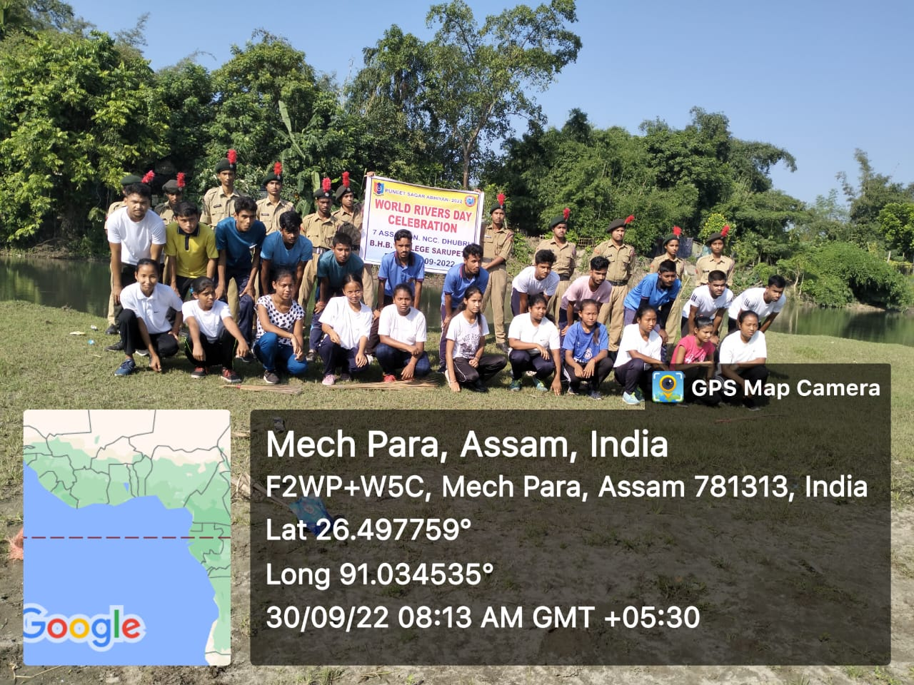

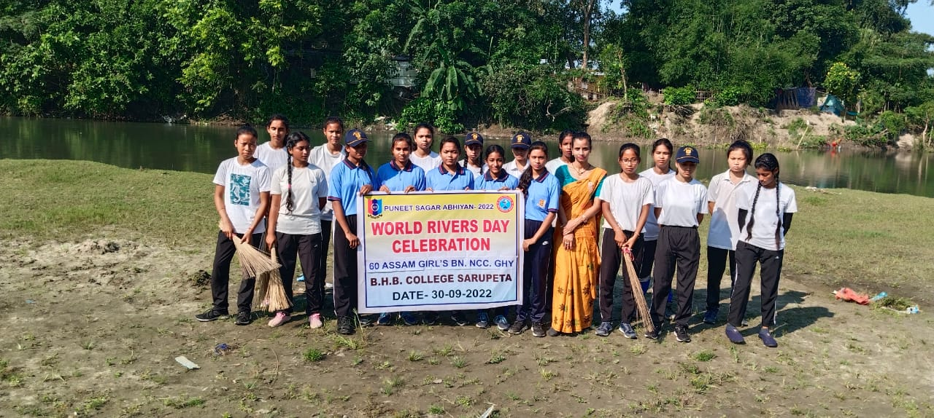
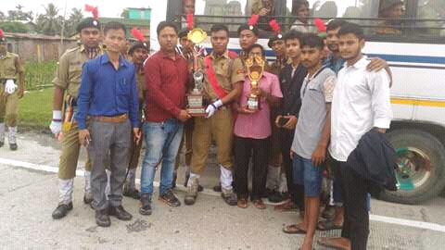
Present Strength of 7 Assam Bn NCC Cadet
Nominal Roll of 1st Year

Sl. No. | Name of Cadets | Regimental No. | D.O.B.
1 | HUSNARA BEGUM | AS2022SWA101550 | 07-09-2006
2 | MUNNIMA KHATUN | AS2022SWA101551 | 02-10-2005
3 | NIHA BARMAN | AS2022SWA101552 | 20-04-2003
4 | MONI BALA DAS | AS2022SWA101553 | 13-02-2006
5 | NABOMI BORO | AS2022SWA101554 | 01-11-2005
6 | JUNUMANI BARMAN | AS2022SWA101555 | 28-11-2003
7 | JAYASHRI KALITA | AS2022SWA101556 | 05-06-2005
8 | RIMPI RAMCHIARY | AS2022SWA101557 | 17-03-2006
9 | MUSKAN AHMED | AS2022SWA101558 | 10-06-2007
10 | KALPANA BASUMATARY | AS2022SWA101559 | 20-03-2005
11 | PUJA TARAFDAR | AS2022SWA101560 | 26-01-2006
12 | PUSPANJALI RAMCHIYARI | AS2022SWA101561 | 16-09-2004
13 | NIRMAL LENDU DAS | AS2022SDA101562 | 27-04-2005
14 | PALLAB KALITA | AS2022SDA101563 | 13-09-2006
15 | UTBHAB MEDHI | AS2022SDA101564 | 28-06-2006
16 | ASHRAFUL ISLAM | AS2022SDA101565 | 10-02-2006
17 | NURUL HOQUE | AS2022SDA101566 | 01-04-2004
18 | PALLAB BARUAH | AS2022SDA101567 | 10-05-2006
19 | EKRAMUL HOQUE | AS2022SDA101568 | 28-04-2003
20 | PULAKESH BORO | AS2022SDA101569 | 27-12-2002
21 | BHRIGUPAM KALITA | AS2022SDA101570 | 23-01-2005
22 | BANAJIT DAS | AS2022SDA101571 | 29-04-2006
23 | INJAMAMUL HOQUE | AS2022SDA101572 | 01-05-2005
24 | SHAJAHAN BADSA | AS2022SDA101573 | 05-12-2005
25 | NUR ISLAM | AS2022SDA101574 | 01-03-2005
26 | SUMAN KALITA | AS2022SDA101575 | 12-05-2005
27 | HRISHIKESH SARMA | AS2022SDA101576 | 04-11-2005
28 | PRASANTA DAS | AS2022SDA101577 | 27-04-2005
29 | PAYEL SARKAR | AS2022SWA101578 | 04-04-2004
30 | ZAKARIYA CHOUDHURY | AS2022SDA101579 | 01-01-2005

Nominal Roll of 2nd Year
Sl. No. | Name of Cadets | Regimental No. | D.O.B.
1 | SUKANATA BARMAN | AS21SDA101538 | 23/06/2003
2 | ALIP BARMAN | AS21SDA101541 | 04/09/2004
3 | RAKIBUL ISLAM |  | 01/01/2004
4 | HAMIDUL ISLAM | AS21SDA101543 | 11/01/2003
5 | ABHINASH BARMAN | AS21SDA101546 | 01/04/2005
6 | MANDEEP KHERKATARY | AS21SDA101916 | 12/03/2005
7 | SWMKHAR NARZARY | AS21SDA101549 | 10/03/2004
8 | TAPAN NATH | AS21SDA101539 | 27/10/2003
9 | DEBARSHI NATH | AS21SDA101544 | 19/10/2002
10 | ANASHRI KALITA | AS21SWA101553 | 20/09/2005
11 | SAGARIKA DEKA | AS21SWA101554 | 10/11/2005
12 | MAMANI BARUAH | AS21SWA101552 | 24/09/2003
13 | JUGAMI GAYARI | AS21SWA101550 | 15/11/2003
14 | MINTU DEKA | AS21SDA101700 | 17/01/2005
15 | DHANANJAY ROY | AS21SDA101699 | 20/04/2004
16 | CHANDAN DAS | AS21SDA101976 | 26/10/2004
17

Nominal Roll of 3rd Year

Sl. No. | Name of Cadets | Regimental No. | D.O.B.
1 | SUMIT SWARGIARY | AS20SDA101911 | 01/10/2001
2 | NIPUL BORO | AS20SDA101912 | 18/05/2002
3 | SWAPAN MANDAL | AS20SDA101913 | 18/03/2000
4 | BHARGAB CHOUDHURY | AS20SDA101915 | 25/08/2004
5 | SADHAN BARMAN | AS20SDA101917 | 05/09/2003
6 | DIPU NATH | AS20SDA101918 | 01/11/2003
7 | NITUL DAS | AS20SDA101919 | 15/09/2003
8 | BABULA DAIMARY | AS20SDA101920 | 11/08/2003
9 | BIKASH MAZUMDAR | AS20SDA101921 | 14/01/2005
10 | HRISHIKESH NATH | AS20SDA101922 | 09/01/2004
11 | DHRUBAJYOTI BARMAN | AS20SDA101923 | 14/03/2004
12 | AMBIKA DAS | AS20SWA101905 | 17/10/2004
13 | SUNAM TARAFDAR | AS20SWA101908 | 12/02/2003
14 | BHARGAB CHOUDHURY | AS20SDA101915 | 25/08/2004

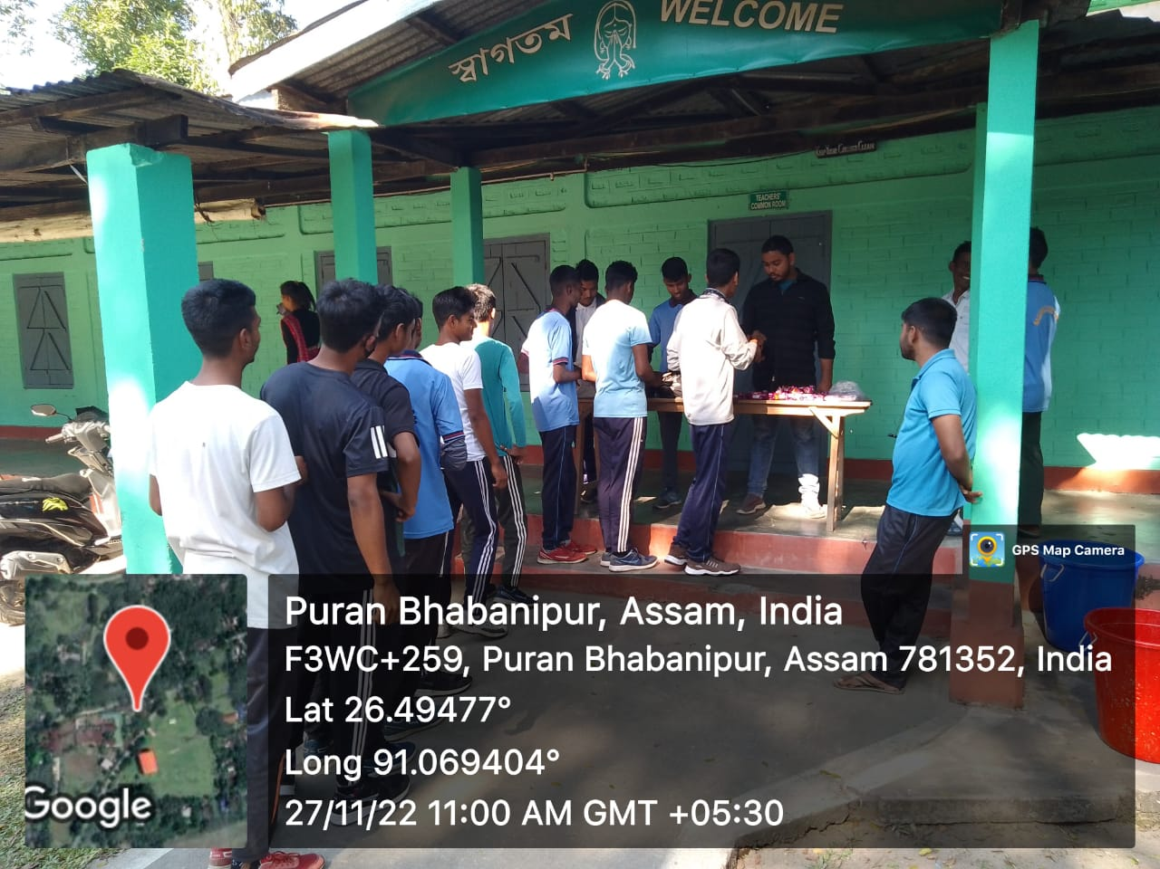

Present Strength of 60 Assam Girl’s Bn NCC Cadet
Nominal Roll of 1st Year

Sl. No. | Name of Cadets | Regimental No. | D.O.B.
1 | ALMINA BEGUM | AS2022SWA108489 | 14-01-2003
2 | KRISHA TALUKDAR | AS2022SWA108492 | 20-11-2005
3 | CHAYANIKA BARMAN | AS2022SWA108500 | 16-12-2005
4 | LIPIKA SAMANTA | AS2022SWA108482 | 03-02-2004
5 | AMINA PARBIN | AS2022SWA108499 | 20-01-2004
6 | PUSPA RAMCHIARY | AS2022SWA108481 | 13-07-2005
7 | DIPA DAS | AS2022SWA108484 | 31-07-2003
8 | MERINA EYASMIN | AS2022SWA108488 | 27-05-2006
9 | ANKITA DAS | AS2022SWA108480 | 25-02-2004
10 | MAUCHUMI SULTANA | AS2022SWA108496 | 10-03-2003
11 | MATU RAMCHIARY | AS2022SWA108503 | 22-07-2004
12 | DIBYA BASUMATARY | AS2022SWA108498 | 03-02-2004
13 | NISHA KALITA | AS2022SWA108483 | 24-11-2003
14 | MALLIKA TALUKDAR | AS2022SWA108490 | 30-09-2005
15 | BINALI BASUMATARY | AS2022SWA108502 | 08-05-2006
16 | PRAMISH RAMCHIARY | AS2022SWA108486 | 14-01-2005
17 | PRIYANSHI KALITA | AS2022SWA108491 | 27-08-2006
18 | SHAYENA AJMIR | AS2022SWA108485 | 01-03-2007
19 | HASINA KHATUN | AS2022SWA108487 | 16-03-2003
20 | DIDWMSRI SWARGIARY | AS2022SWA108494 | 15-02-2005
21 | BARNALI BARO | AS2022SWA108495 | 24-12-2004
22 | ASMINA AHMED | AS2022SWA108501 | 15-04-2006

