Celebration of N.C.C. Day, 2020
N.C.C. Day has observed at B.H.B. College, Sarupeta maintaining all the Covid-protocol on 4th Sunday, November, 2020. Assistant Professor and Ex-C.T.O. of N.C.C. Dr. Nomita Das Gurung presided the meeting of the celebration of N.C.C. Day. Invitee chief guest Ranjit Kalita, C.T.O. Rajiv Thengal, senior and junior cadets were present in the meeting. Invitee guest Ranjit Kalita unfurls the N.C.C. flag and N.C.C. song was sung by the cadets. After singing N.C.C. song cadets perform the N.C.C. parade. This year N.C.C. Unit of B.H.B. College selected two cadets from boys and girls as the best cadet of the year and an award has been given each of the two best cadets. The award sponsored by Dr. Nomita Das Gurung for the best cadet from girls and the award for the boys sponsored by Ex-Army Praneswar Baisya. Ex-C.T.O., C.T.O, chief guest, non-teaching staff Debo Talukdar, senior cadet Hiranya Das, Dhanjit Kalita, Poragmoni Barman delivered speech in the meeting. Tree sapling has also been planted in the occasion of N.C.C. Day.

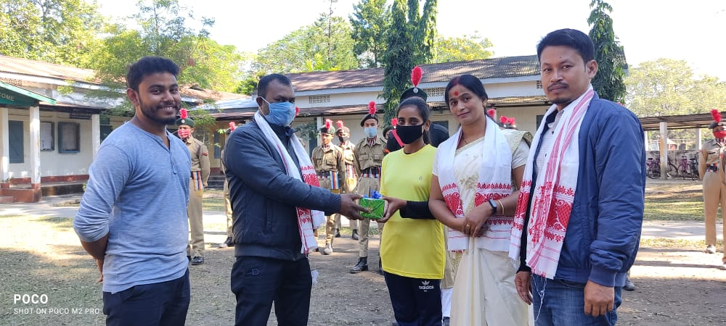
The Best Cadet of the Girls, the Award presented to Rima Begum sponsored by Dr. Nomita Das Gurung

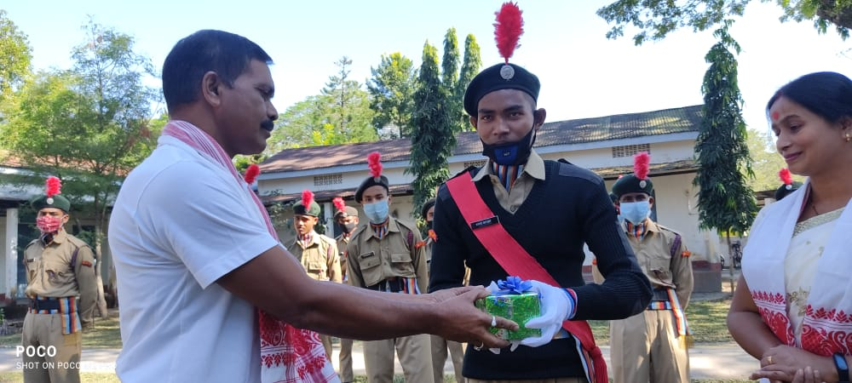
The Best Cadet of the Boys, the Award presented to Bishwo Goyary sponsored by Ex-Army PraneswarBaishya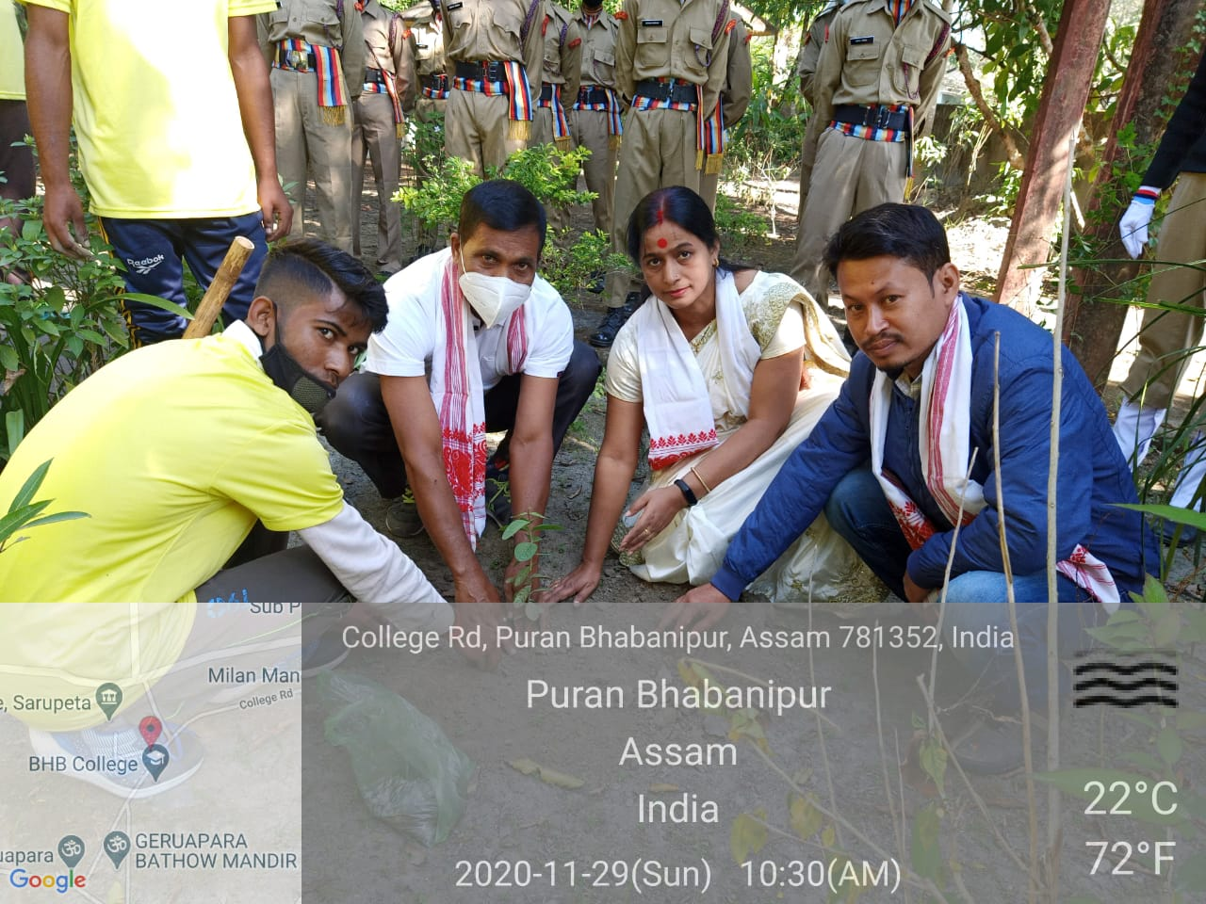
Tree Plantation on the Occasion of N.C.C. Day.

