Report on the Celebration of World Environment Day at B.H.B. College, Sarupeta.
BHB College, June 6: Yesterday, on the occasion of World Environment Day, the B.H.B. College fraternity has observed it in the college campus by planting the saplings of some trees. B.H.B. college is situated in the Barpeta District of Assam and acts under Gauhati University.
As the government have currently been using the college campus as 'Quarantine Centre,” no student was allowed to take part in that programme and they were advised to celebrate it from their respective homes. In the college campus, a small tree plantation programme was organised by the college fraternity in presence of the members of teaching and non- teaching staff of the college. This tree plantation programme was held under the guidance of the principal of the college Dr. Birinchi kr. Das.
All the NSS volunteers and many other students planted the saplings at their respective homes. The programme Officer of the NSS unit B.H.B. College, Sarupeta, Mr.Nabamoni Saikia made an interaction with NSS volunteers of the college on 4th June in WhatsApp group and advised them to plant sapling on the next day and also to take care of that planted tree. He asked them to post a photo of tree plantation by each volunteer in the WhatsApp group as proof.
NSS volunteers of the college responded the call very well and all the 29 volunteers of the college planted saplings in their respective homes and posted their photo in the NSS WhatsApp group of the college. In the afternoon, two volunteers have also attended a Zoom meeting organised by the NSS cell, Gauhati university.
Two NSS Volunteers of our college, namely Hillol Pathak and Mitul Das, informed me that both of them have given 5 saplings to their neighbours and asked them look after those saplings.
Mr. Nabamoni Saikia
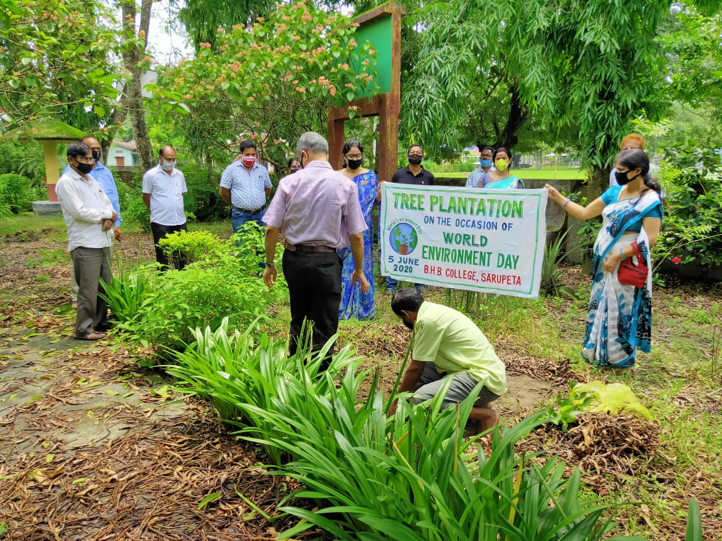
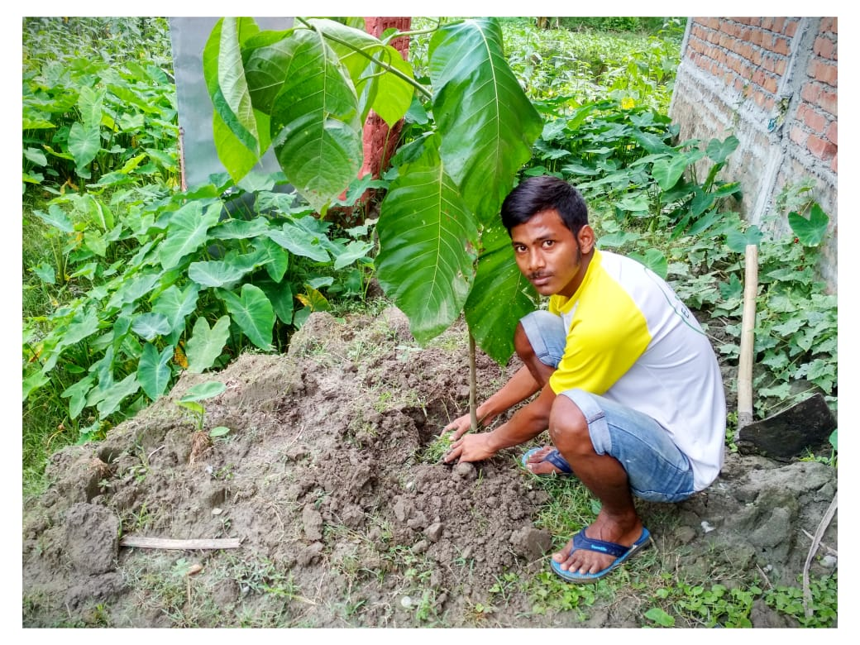
Programme Officer, NSS Unit, B.H.B. College, Sarupeta, Barpeta, Assam.
