Gandhi Jayanti Celebrated.
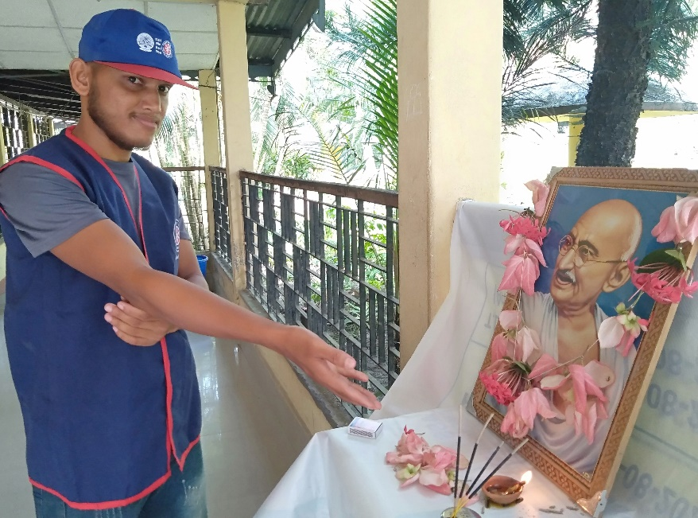
BHB College, Sarupeta, 2nd October, 2021: Today, on the auspicious occasion of Gandhi Jayanti, the NSS Unit of BHB College has paid their reverence to that great soul of our nation. The programme was started with the lightening of earthen lamp by the Programme Officer of the NSS Unit, Naba Moni Saikia, who also delivered a speech on the greatness of the occasion and asked the NSS volunteers to follow the teachings of Gandhi. Two volunteers also delivered brief speech on the greatness of Gandhi. All the volunteers pay their tribute to that great soul by offering flowers in front of his picture.

