Lecture on Mahatma Gandhi
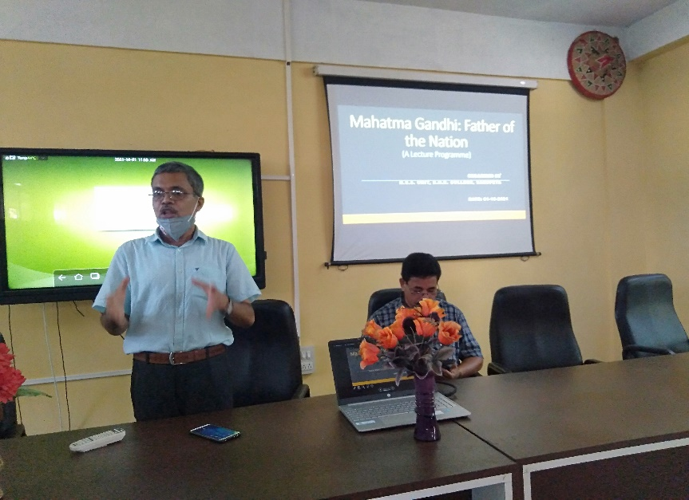
BHB College, Sarupeta, 1st October, 2021: Today, the NSS unit of BHB College, Sarupeta has organized an one-day lecture programme with a view of creating awareness about Gandhi’s ideals and its importance in the present scenario amongst the students. The title of the lecture is ‘Mahatma Gandhi: Father of the Nation’ where the resource persons delivered their lectures and share their knowledge with students. Dr. Birinchi Kr. Das, the principal of the college presided over the programme and also delivered a valuable lecture on the importance of Gandhian philosophies. He asked the students to follow the teachings of Gandhi in their life and thereby to make their parents, society and nation proud on them. Md Mofuzzal Hussain, HoD of History Department and also the resource person of this lecture programme, has delivered his lecture on Gandhi’s role in eradication of social discrimination from the society from the historical point of view. He satisfied many curious students with his vast and deep knowledge on the topic. Another resource person, Upen Barman, HoD of Education department of the college gave a speech on Gandhi’s views in Indian education system by including many interesting aspects like Gandhi’s views on women education, importance of the teaching of vernacular languages in the school etc. Along with the teachers of this college more then 70 students attended the lecture programme and made it a successful one. Mr. Naba Moni Saikia, the programme officer of the NSS Unit of BHB College anchored the programme and also delivered the vote of thanks.

