NSS Orientation Programme Held.
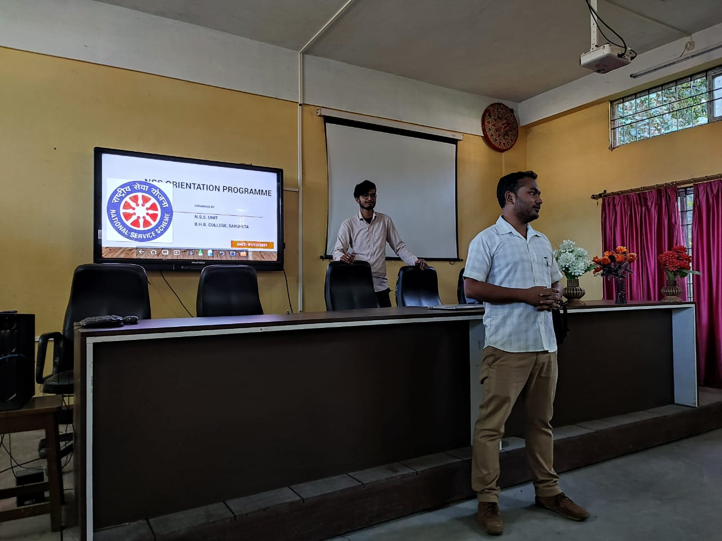
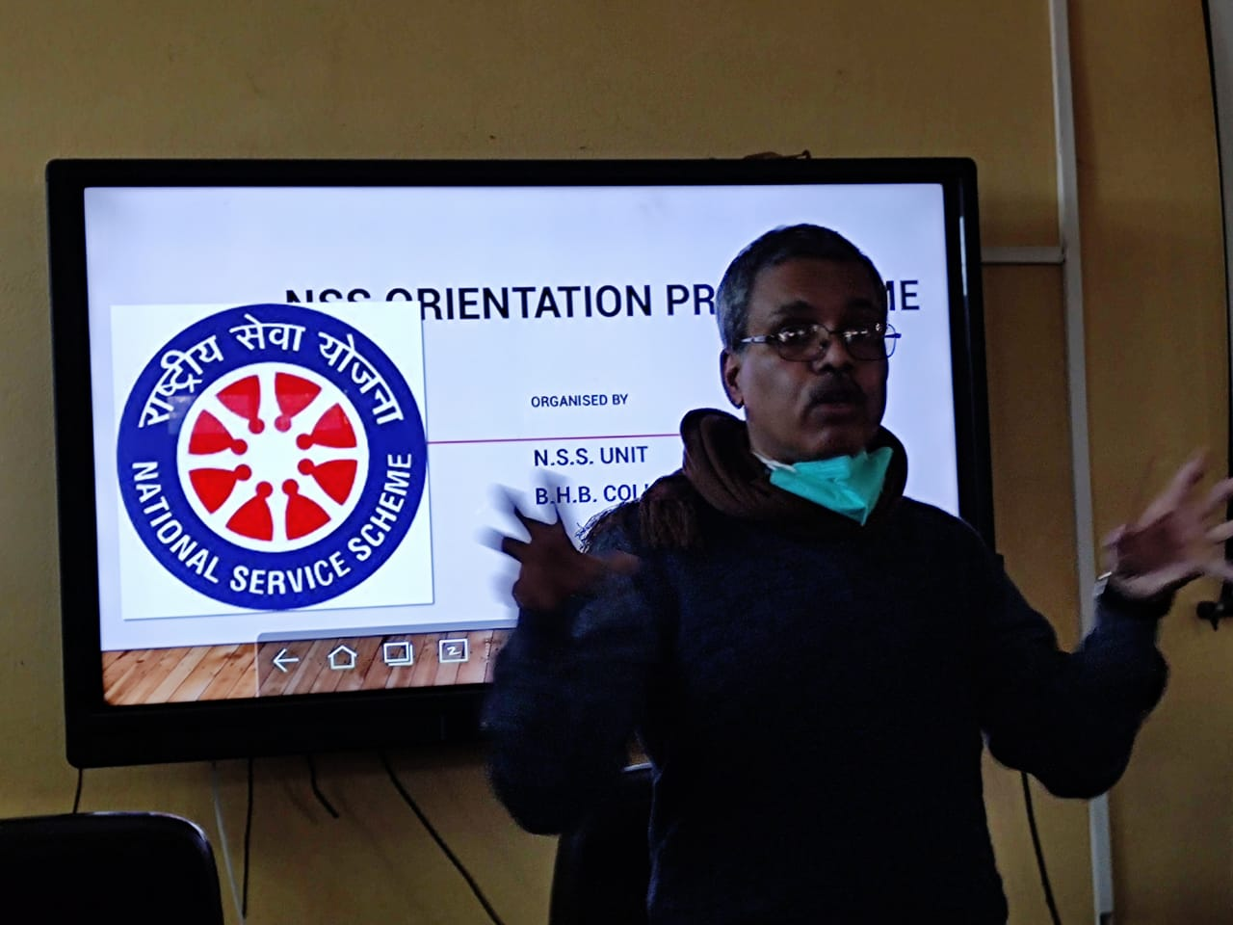
BHB College, 1st December: Today, the NSS Unit of BHB College organized an orientation programme for the new volunteers who enrolled their names as NSS volunteer in this year. The programme was started with a short introductory speech of the principal, Dr. Brinchi kr. Das. In his speech, he elaborated the role of NSS in nation building and the personality development of the students. After that with the help of PowerPoint presentation Mr. Naba Moni Saikia, programme officer of the NSS Unit of BHB College delivered a lecture in front of all the newly enrolled NSS Volunteers and give them details about the origin, objectives, aims, motto and the importance of NSS in the personality development of students. He also shared the future plans of the NSS Unit and asked them to contribute to make this dreams real. He also selected two students from HS and Two students from BA as the group leaders and asked all the volunteers to maintain self-discipline and punctuality throughout their life. In that programme, a session of discussion was also held where the newly enrolled volunteers asked the resource person some question which he answered. More then 70 newly enrolled volunteers and almost 30 former volunteers joined the programme.
