Cleanliness Drive by NSS
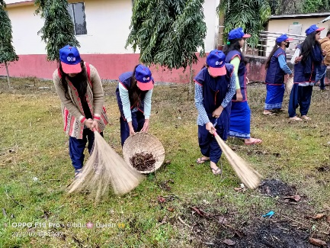
4th January, 2022, B.H.B. College, Sarupeta : The N.S.S. wing of B.H.B. College, Sarupeta organized a cleanliness drive on 4th February, 2022 in the college campus. The primary objective of the programme was to inculcate in the students the habit of cleaning the college campus. Keeping in view the goals of the Swachh Bharat Abhijan, the NSS frequently organizes the college cleanliness programme to instill the practice of keeping the college campus clean and green. Nabamoni Saikia, Asst., Professor and coordinator of the NSS wing assembled the students for the drive. A total of 20 cadets joined the drive and rendered their valuable service. Such initiatives induce discipline, team spirit, synergy among the students and sensitize them about importance of hygiene and the necessity to keep their environment clean.
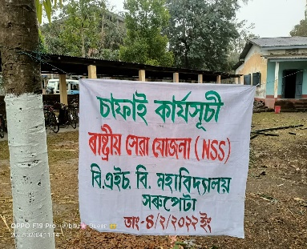

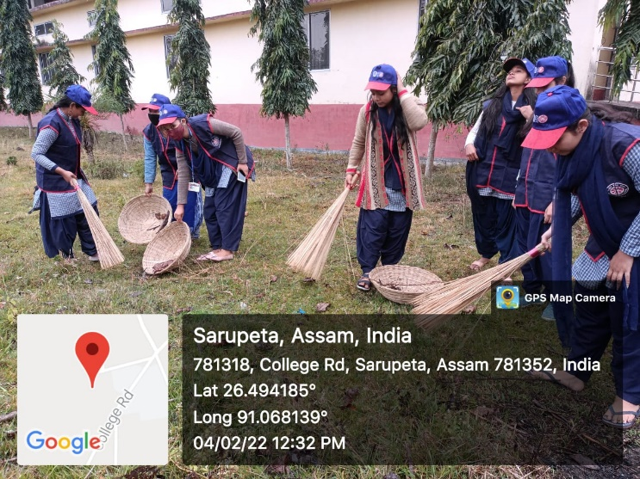
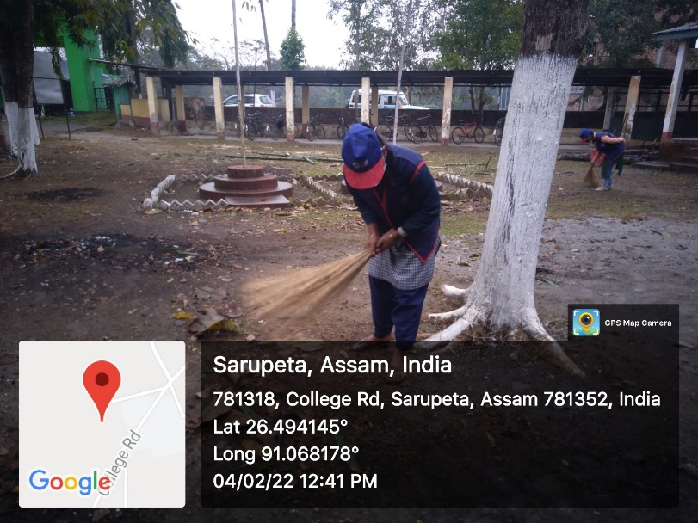
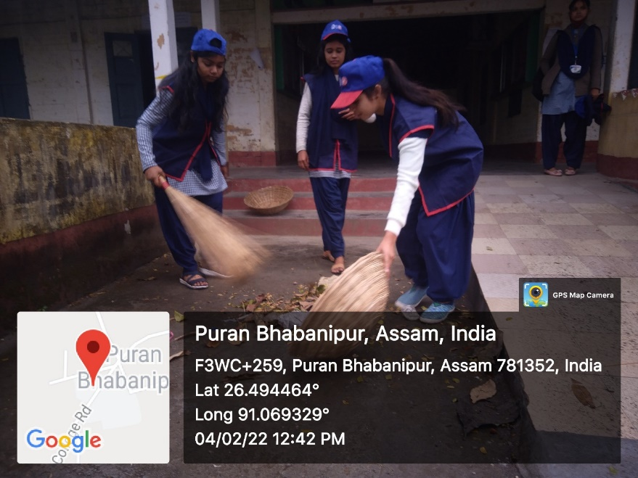
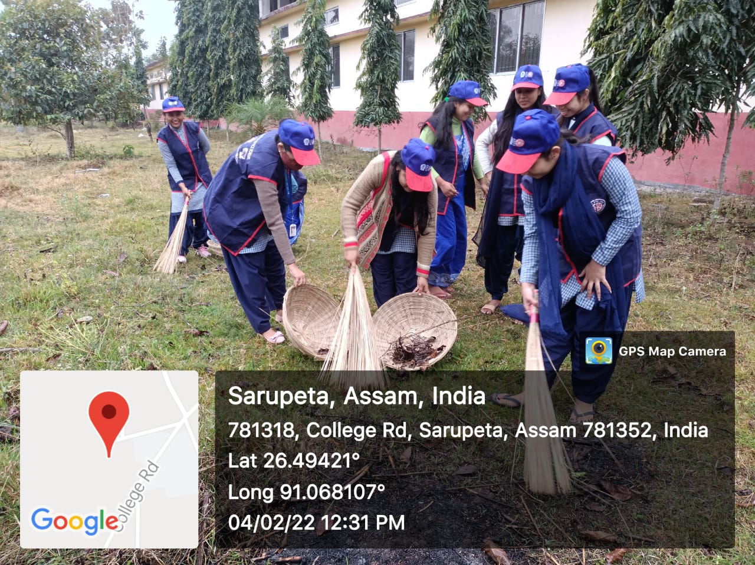
Report Submitted by-
Mr. Naba Moni Saikia
Programme Officer
NSS Unit,
B.H.B. College, Sarupeta.

