NSS Unit Organized Plantation Drive
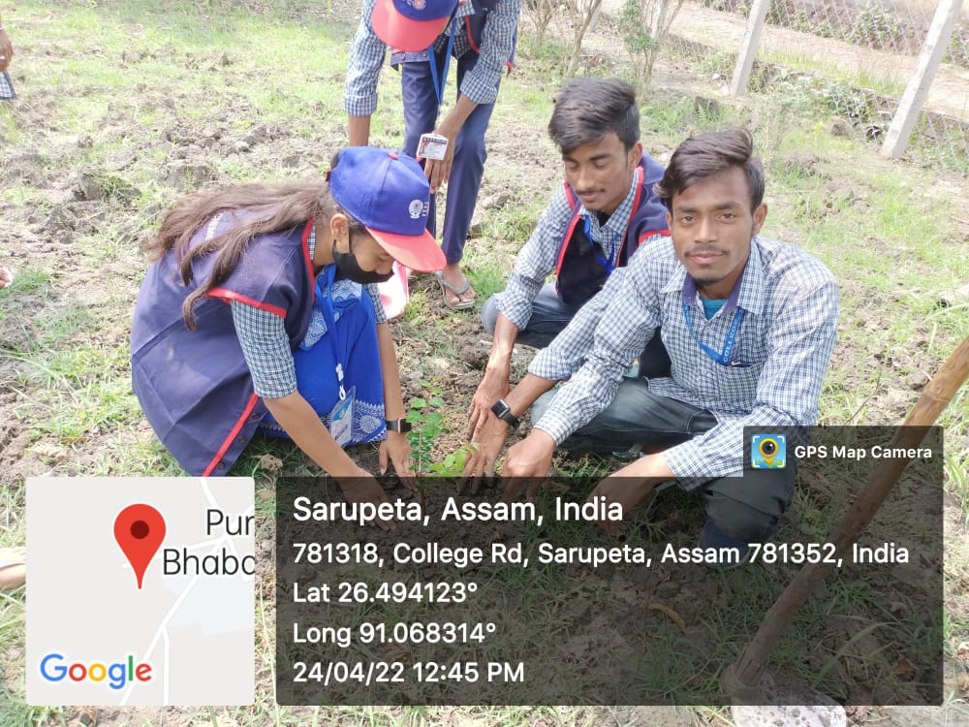
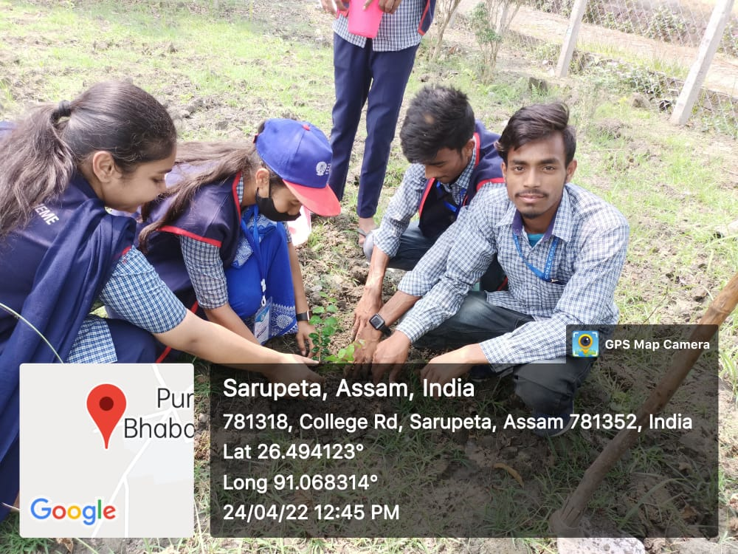
April 24, 2022, Sarupeta: Volunteers of NSS Unit, BHB College, Sarupeta organized today a plantation Drive inside the college campus on the auspicious occasion of the final day of Golden Jubilee Celebration by the College fraternity. The plantation programme was started at 10 am. And Jitendra Kumar Choudhury, the senior journalist of Dainik Asom and also an alumni of the college graced the programme by participating as chief planter. Dr. Birinchi Kr. Das, Principal of the college and othe members of the college family along with the volunteers actively participated in that programme. Today 30 NSS volunteers planted saplings of varied trees and flowers like Bokul, Krishnachura, Pamela etc in front of college indoor stadium, NSS garden and also in in the edge of the street.
