Plantation Drive
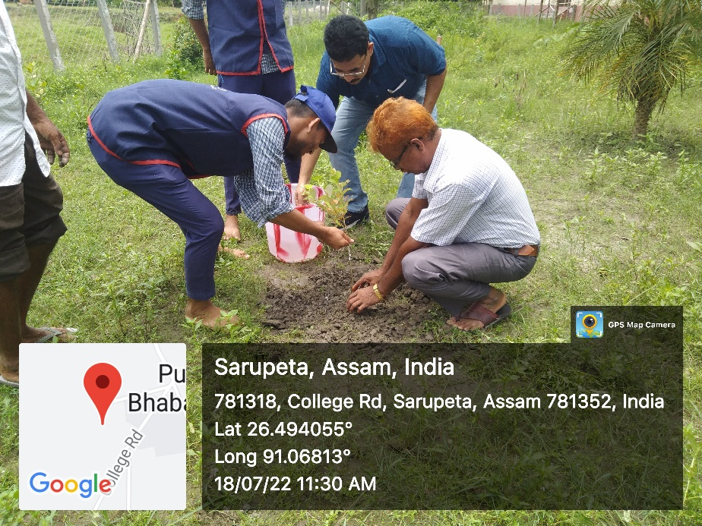
BHB College, July 18, 2022: As part of Chief Minister’s Institutional Plantation Programme, a plantation drive was organized today by the NSS Unit of BHB College. Twenty five saplings were planted on the occasion and 40 volunteers participated in it. In-charge principal Mofuzzal Hussain inaugurated the drive by planting a tree and spoke briefly about the importance of making and keeping our environment green and clean.

