NSS Unit Participated in Annual Cultural Procession Competition of the College.
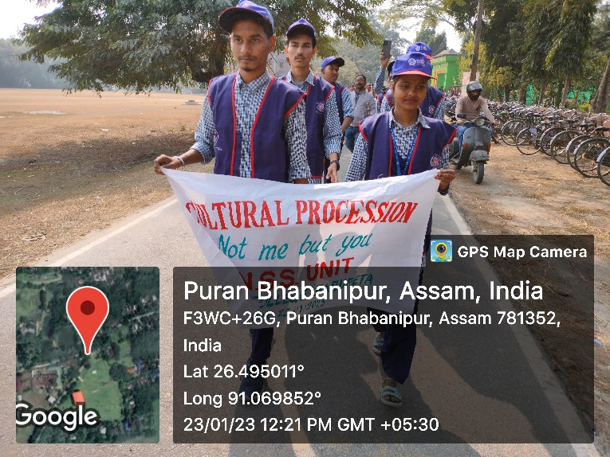
29 January, 2023: The NSS Unit of BHB College, Sarupeta has participated in the annual cultural procession competition of the college. Almost 25 students participated in that NSS team.

