NSS SPECIAL CAMP
Organised by NSS UNIT, BHB College, Sarupeta
At Puran Bhabanipur Gaon.
From 18-02-2022 to 25-02-2022

1st Day Report

Puran Bhawanipur Gaon, February 18, 2020: From today onwards the NSS Unit of BHB College, Sarupeta have started their NSS Special Camp at Puran Bhawanipur Gaon, the adopted village of the NSS Unit of BHB College, for the upcoming seven days. As a part of the Special Camp, an inaugural programme was organised by the NSS Unit at 309 No. Puran Bhawanipur LP School and also did plantation after the inaugural programme. The inaugural programme was anchored by Hiyangkona Das, an NSS Volunteer and the meeting was presided over by Mofazzul Hussain, Head of the History dept. Of BHB College, Sarupeta. As the special guest, Dr. Birinchi kr Das, principal of BHB College delivered his lecture by focusing on various issues like the objective of NSS, its work module, the reason behind the adoption of this village etc. The IQAC Coordinator of BHB College, Phanidhar Mech also attended the programme and asked the villagers to cooperate with NSS volunteers for the all-round development of their village. On behalf of villagers of Puran Bhawanipur, Mr Gopinath Biswas, a businessman and also a villager of Puran Bhawanipur, offered his gratitude towards the college and NSS Unit for adopting their village and promised to help NSS volunteers in every possible aspect. Mr. Dolachan Daimary, the Gaonburha of Puran Bhawanipur attended the inaugural programme and asked every villager to help the NSS volunteers these days. 65 NSS Volunteers along with the students and teachers of 309 No. Puran Bhawanipur LP School and more than 50 villagers attended the programme today. The vote of thanks was offered by Dr. Namita Das Gurung. After the conclusion of the inaugural programme, a small plantation programme was also done by the NSS Volunteers in the field of 309 No. Puran Bhawanipur LP School.

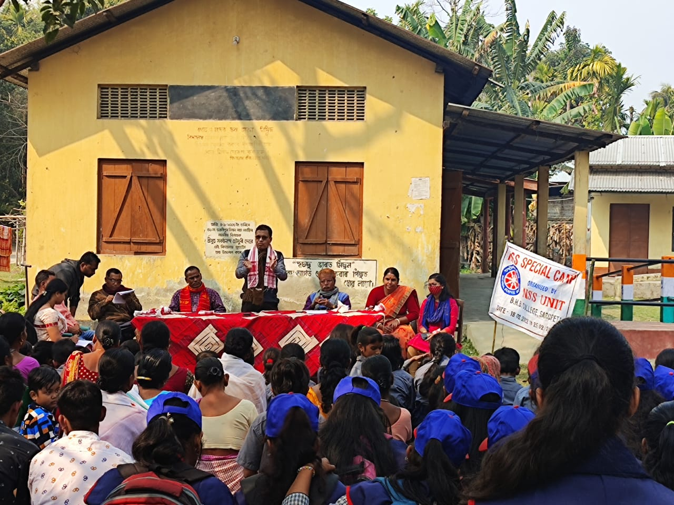

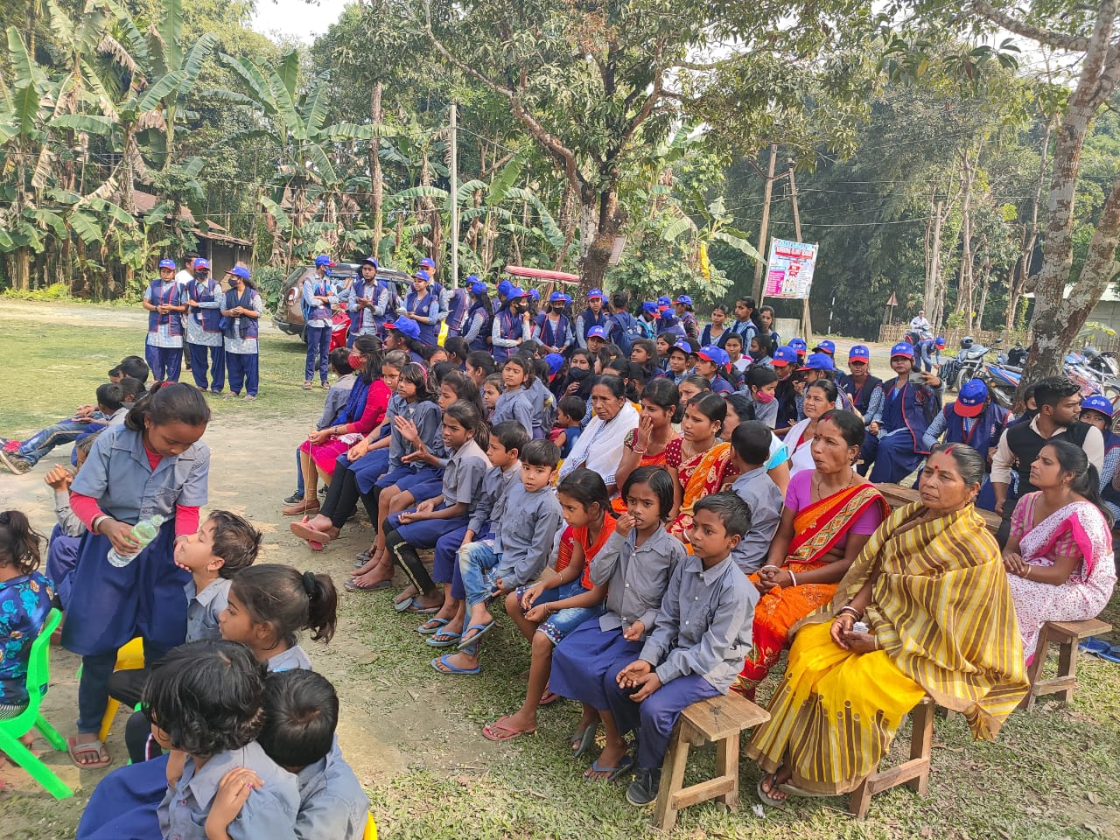
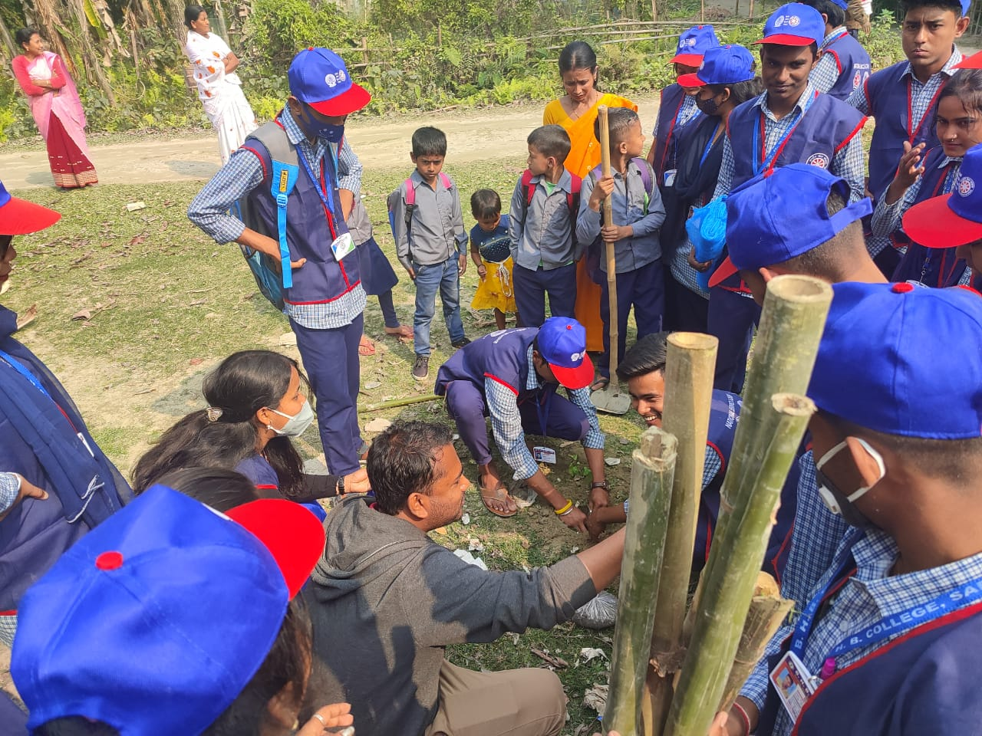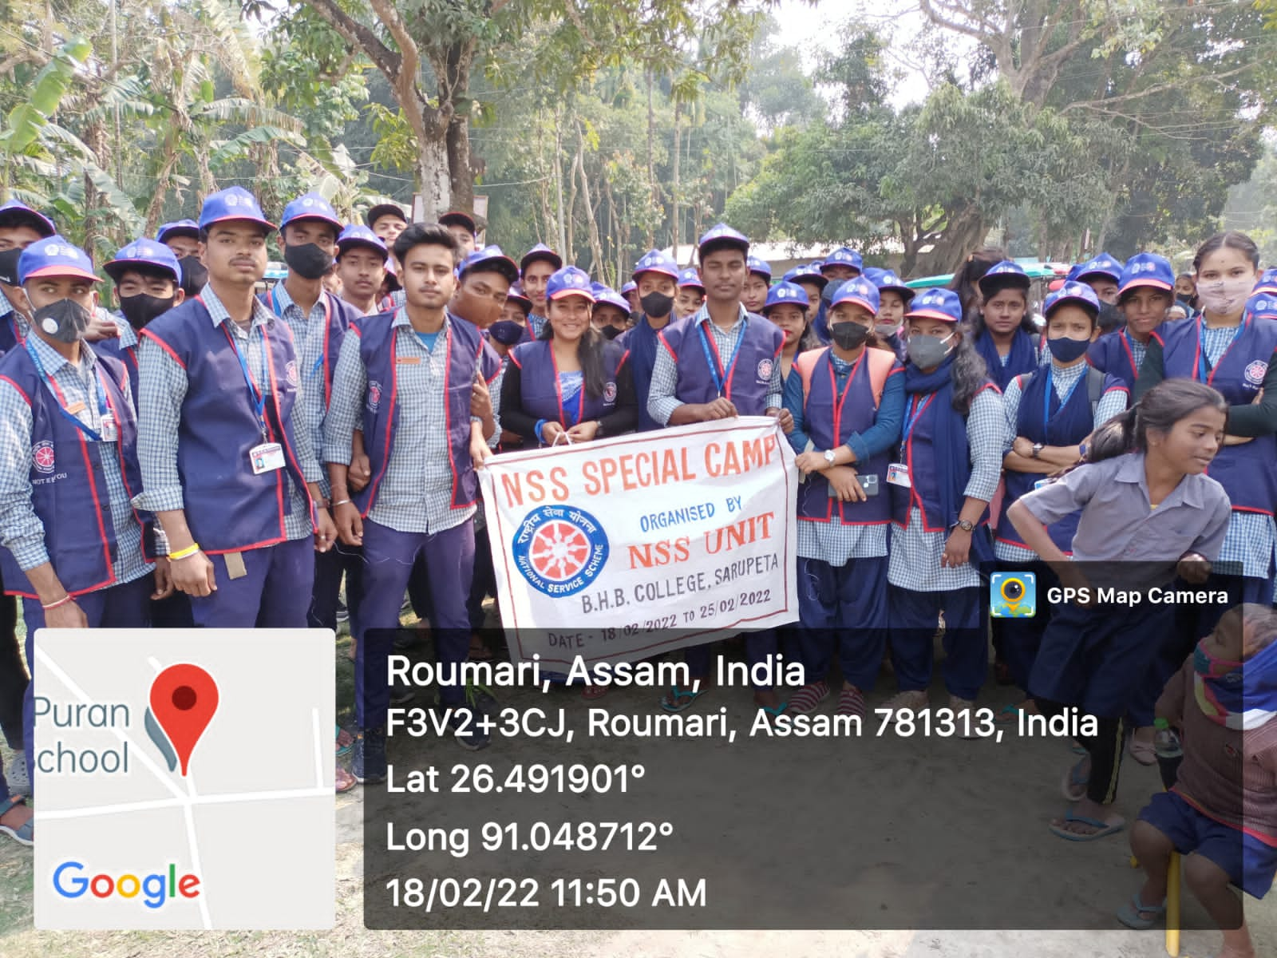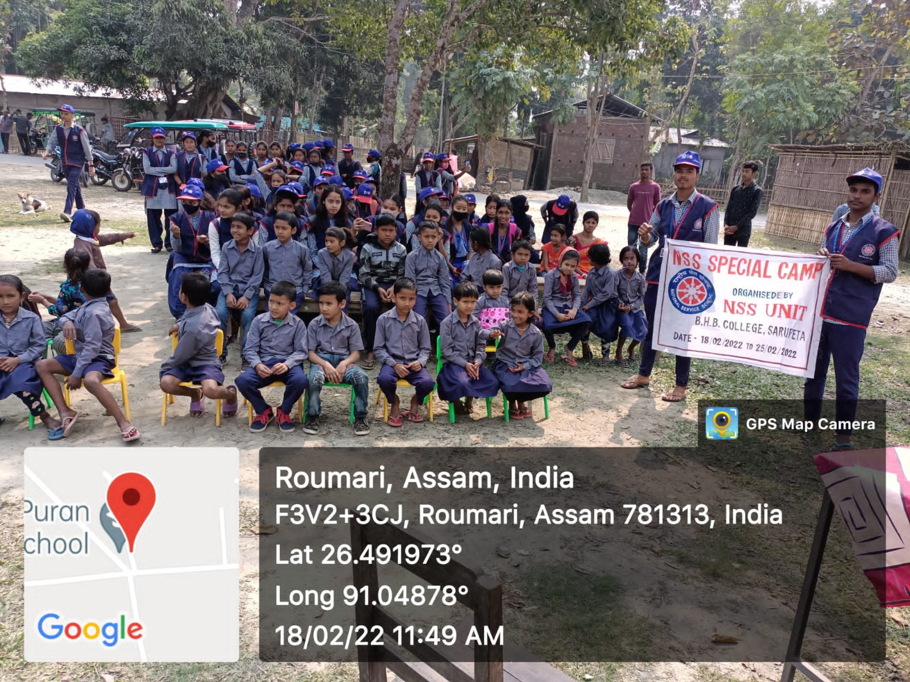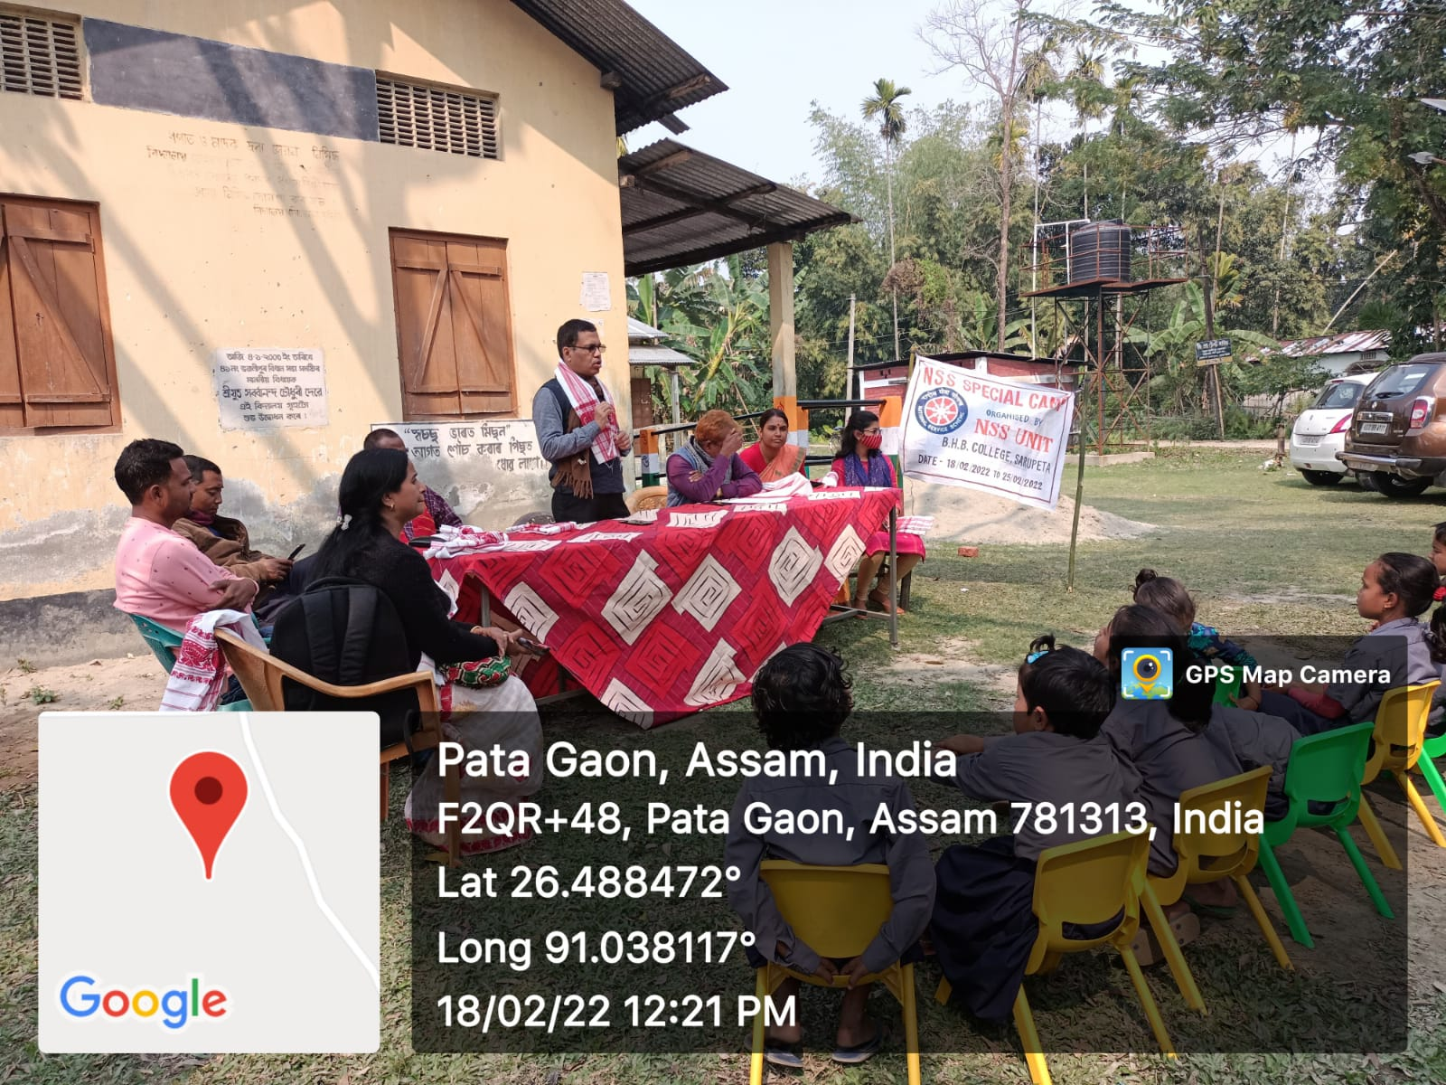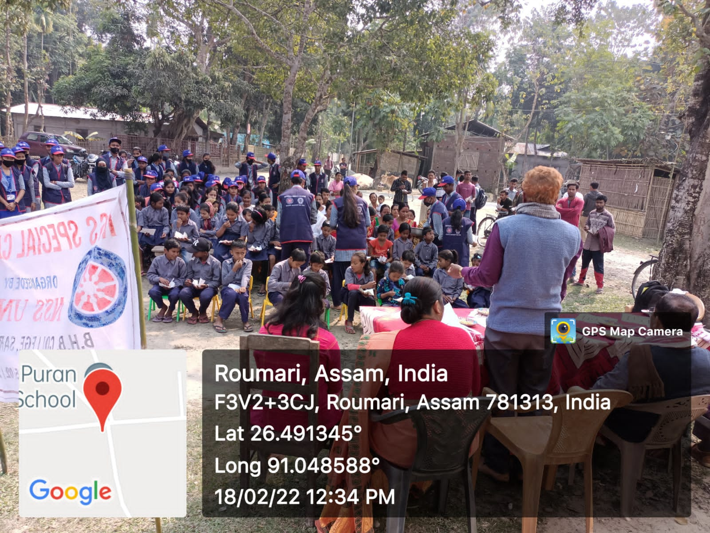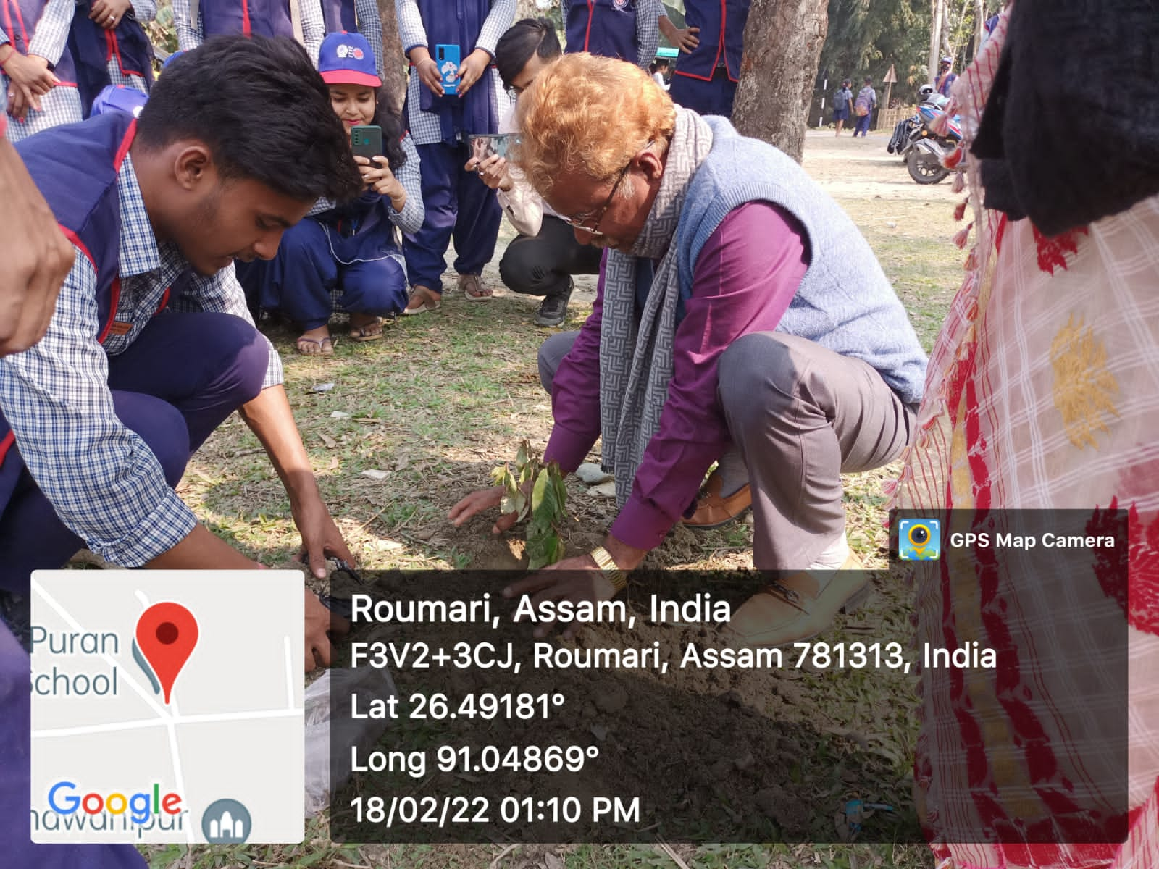
Report Prepared by-
Mr. Naba Moni Saikia
Programme Officer
NSS Unit
BHB College, Sarupeta.

